**Simulation of Proposed GHG-Reduction Solutions**

**with Open-Source Energy Storage Model**

${Ryan Mann}^{1, 2}$, ${Jan Grygier }^{3}$

$^{1}$ Storage and DER Project Analyst at Enel EnerNOC

$^{2}$ Grid Data Analysis Volunteer at WattTime

$^{3}$ Principal, Strategic Quantitative Analysis and Modeling at Pacific Gas and Electric Company

I. BACKGROUND

The Self-Generation Incentive Program (SGIP) working group established by the California Public Utilities Commission (CPUC) was tasked with developing “a proposal for a greenhouse gas signal and enforcement mechanism for energy storage systems participating in the Self-Generation Incentive Program to ensure these projects reduce greenhouse gas [GHG] emissions.” In its first meeting, the Working Group highlighted modeling the effectiveness and economic impact of potential GHG-reduction solutions as its primary method of identifying preferred solutions. However, the initially-proposed modeling process relied heavily on the use of behind-the-meter storage technology companies’ proprietary and confidential dispatch modeling software, which posed challenges for the Working Group’s ability to identify discrepancies in modeling methodology and results, and come to consensus.

To address this concern, several stakeholders proposed using an open-source energy storage model (OSESMO). Unlike the proprietary models, OSESMO’s methodology could be shared with the Working Group and with the Commission, including its source code being freely available on GitHub[1]. In addition, unlike the proprietary model results, which could only be shared with the Working Group and Commission after being aggregated and anonymized, OSESMO’s result outputs could be published and presented individually. This meant that the public-model results could be shared with proprietary modelers, allowing for comparison and validation without proprietary results needing to be shared with the group.

OSESMO’s fast runtime and programmatic design allowed it to be used to model many more scenarios (consisting of residential or commercial/industrial load profiles, retail rates, storage hardware parameters, and storage dispatch approaches) than the proprietary models, and it therefore became a de-facto benchmark with which the proprietary model results were compared.

II. METHODOLOGY

*A. Overview*

OSESMO was intended to offer similar sophistication to the software used by energy storage technology providers for pre-sales modeling and real-time storage dispatch. It is also seemingly quite similar in structure to the E3 RESTORE model[2] used in the 2016 SGIP Impact Report, as well as to the EPRI StorageVET model[3]. Most significantly, unlike a spreadsheet-based model or a rules-based storage dispatch model, OSESMO’s approach is based on mathematical optimization, a field of mathematics and computer science. Optimization algorithms are used to solve large and complex problems where the objective is to minimize or maximize a function, often subject to a number of constraints.

In this case, the dispatch (charge/discharge) behavior of customer-sited energy storage systems can be simulated with an optimization-based model where the objective is to minimize the customer’s monthly bill. The primary advantage of optimization-based storage control over rules-based storage control is the ability to effectively provide value across multiple, often competing, economic value streams, such as demand charge reduction and time-of-use energy charge arbitrage. In the case of OSESMO’s usage by the SGIP GHG Working Group, an optimization-based model structure also offers the ability to co-optimize between customer bill savings and GHG reduction, which opens the possibility of emissions reduction with little to no impact on the storage system’s ability to provide other economic value streams. This optimization-based structure was also leveraged in the creation of the Non-Economic Solar Self-Supply dispatch algorithm, which encourages solar self-consumption even when uneconomic, such as for residential solar-plus-storage customers on a non-TOU rate. The Solar Self-Supply algorithm allows the system to respond to infrequent economic signals, such as SmartRate critical peak pricing events, as well as to an economic GHG signal.

OSESMO uses a well-established mathematical optimization technique known as linear programming that allows large problems to be solved quickly. In this case, OSESMO is capable of finding the optimal charge-discharge dispatch strategy for all 15-minute time intervals in the year 2017 in under 10 seconds. This makes it possible to perform thousands of model runs, evaluating the impact of the proposed GHG reduction solutions for all combinations of a large number of inputs, across a representative set of load profiles and retail rates.

It’s important to note that OSESMO does not perform load forecasting, as production storage-dispatch software does, instead assuming perfect knowledge of historical load. Load forecast accuracy affects the operation of energy storage when performing demand charge reduction; more accurate forecasting increases the amount of savings achieved and decreases the need for unnecessary battery cycling. Thus, results for commercial & industrial customers are less representative of actual storage system behavior than results for residential customers, and should be compared to results from other modelers whose dispatch-simulation software includes load forecasts.

*B. Cost Function*

OSESMO simultaneously co-optimizes the customer’s retail energy and demand charges, carbon emissions (for GHG Signal model runs), as well as unnecessary battery cycling and degradation. This is formulated mathematically as follows:

$$\operatorname{minimize}{\sum_{t=1}^{N}{{(c}_{energy}(t){+ c}_{carbon}(t)){*(P}_{ES,in}\left(t\right)- P_{ES,out}\left(t\right))* Δt}}+$$

$$\left(\frac{η_{charge}{* c}_{cycle}}{2* S_{ES}}\right){*P}_{ES,in}\left(t\right)*Δt+$$

$${\left(\frac{c_{cycle}}{η_{discharge}* 2* S_{ES}}\right)* P}_{ES,out}\left(t\right)* Δt+$$

$0*E(t)$ +

$$c_{demand,NC}*P_{max, NC}+$$

$$c_{demand,CPK}*P_{max,CPK}+$$

$$c_{demand,CPP}*P_{max, CPP}$$

|  |  |  |
| --- | --- | --- |
| **Variable** | **Definition** | **Units** |
| $$c_{energy}(t)$$ | Volumetric energy rate. | $/kWh |
| $$c_{carbon}(t)$$ | Dynamic emissions-based economic signal. Equal to marginal emissions (metric tons ${CO}_{2}$/MWh) * carbon adder ($/metric ton) *  (1 MWh/1000 kWh). | $/kWh |
| $$P_{load}(t)$$ | Original customer load. | kW |
| $$Δt$$ | Model timestep length. | hours |
| $$η_{charge}$$ | Single-cycle charging efficiency of the battery. | % |
| $$c_{cycle}$$ | Degradation cost per battery charge-discharge cycle. | $/cycle |
| $$S_{ES}$$ | Nameplate energy capacity of the battery. | kWh |
| $$P_{ES,in}(t)$$ | Power used to charge the battery. | kW |
| $$η_{discharge}$$ | Single-cycle discharging efficiency of the battery. | % |
| $$P_{ES,out}(t)$$ | Power discharged from the battery. | kW |
| $$E(t)$$ | Energy level of the battery, analogous to state-of-charge. | kWh |
| $$c_{demand, NC}$$ | Noncoincident maximum demand charge rate. | $/kW |
| $$P_{max,NC}$$ | Noncoincident maximum monthly demand. | kW |
| $$c_{demand, CPK}$$ | Coincident peak demand charge rate. | $/kW |
| $$P_{max,CPK}$$ | Coincident peak maximum monthly demand. | kW |
| $$c_{demand, CPP}$$ | Coincident part-peak demand charge rate. | $/kW |
| $$P_{max,CPP}$$ | Coincident part-peak maximum monthly demand. | kW |

The objective function to be minimized represents the total variable customer cost over the set time horizon. This cost has a number of components:

1. The net customer demand in each timestep (gross customer demand, minus power produced by solar if applicable, plus power consumed/generated by the battery, is multiplied by the volumetric energy rate.
2. The emissions impact in each timestep, equal to the net customer demand multiplied by the forecasted or real-time carbon emissions rate, is multiplied by a carbon price.
3. The battery has a limited cycle life (assumed 10 years of daily cycling until the battery is degraded to 80% of its original capacity), so all power going into or out of the battery incurs a cost on the value of the asset. Note that this cycling penalty only applies to lithium-ion batteries; flow batteries do not experience this cycling-related degradation.
4. Depending on the rate structure, the customer may pay a noncoincident demand charge that is based on the highest 15-minute demand in each month (regardless of the time of day). The customer may also pay up to two additional coincident demand charges: one based on the highest 15-minute demand occurring during peak hours, and another based on the highest 15-minute demand occurring during part-peak hours. Some tariffs only have a single coincident peak or part-peak demand charge, some only have noncoincident demand charges, and some do not have any demand charges.
5. There is no cost associated with the energy level of the battery, but it must be included as a decision variable with an associated cost of $0 in order to be included in the constraint equations. This cost could be changed to a negative value to give the model a preference for high states of charge (to prepare for demand-response events).

*C. Constraints*

The behavior of the storage system is also subject to a number of constraints. Some of these constraints are representations of physical limitations on the battery’s dispatch (for instance, it cannot be more than 100% full or less than 0% full), whereas others are operational requirements, such as the need to charge from solar to receive the Investment Tax Credit.

1. The difference in the energy level of the battery between timesteps is equal to charging power minus discharging power, multiplied by the timestep length, with an efficiency penalty on both battery charge and discharge. This constraint applies for Timestep 1 through Timestep (N-1).

2. Power flowing into or out of the battery must be less than or equal to the rated power of the battery (or battery inverter), and greater than 0 kW. Power flowing into the battery includes both power from the PV system and power from the grid.

3. The energy level of the battery cannot be below 0 kWh, or above the nameplate energy capacity of the battery.

4. The state of charge/energy level of the battery is set to 30% (0.3 $S_{ES})$* at the beginning and end of the year. The optimization algorithm will most likely discharge the battery as much as possible in the final timesteps of the time horizon to minimize the customer’s bill, a “greedy” dispatch action that would not be seen during continuous operation with an infinite time horizon. To create more realistic charge/discharge profiles, the time horizon (here, a calendar-month billing period) is “padded” with extra days at the end to ensure that the final energy levels are as close as possible to the values that would be seen during continuous operation. The initial state of charge in all months after the first is set based on the state of charge and charging/discharging power in the final unpadded timestep from the prior month to ensure continuity.

5. To mathematically represent demand charges while keeping a linear-program optimization format (including a maximum() function in the cost-function would make the problem nonlinear), an upper bound on net demand is set as a decision variable, and then a constraint is added to ensure that net demand in all timesteps is less than the optimally-set upper bound. If there is on-site PV generating electricity, net load includes the solar system’s output in addition to the original customer load and the storage’s charge/discharge power.

6. The above equation applies to the noncoincident demand charge, which applies to all timesteps in the month. The coincident peak demand charge below applies only to timesteps that fall during peak TOU periods.

7. The coincident part-peak demand charge below applies only to timesteps that fall during part-peak TOU periods.

8. If the solar plus storage system is claiming the Investment Tax Credit for the storage system, it must be charged at least 75% from solar. However, the ITC amount is prorated by the amount of energy entering into the battery that comes from solar (ex. a storage system charged 90% from solar receives 90% of the ITC). As a result, the optimal amount of solar charging is likely higher than the minimum requirement of 75%, and likely very close to 100%. For simplicity, this formulation of the constraint requires the storage system to charge 100% from solar.

9. In its response to Stem’s Petition for Modification to the SGIP round-trip efficiency requirement, PG&E suggested a set of constraints on charging and discharging times as a proposed method for reducing greenhouse gas emissions associated with storage dispatch. Specifically, at least 50% of total charging would need to occur between 9:00 am and 2:00 pm (the Charging Time Constraint), and at least 50% of total discharging would need to occur between 4:00 pm and 9:00 pm (the Discharging Time Constraint). Charging would also not be allowed to occur between 4:00 pm and 9:00 pm (the No-Charging Time Constraint).

Derivation of Charging Time Constraint in standard linear form $Ax≤b$:

$$\frac{\sum_{t=1}^{N}{P_{ES,in}\left(t \{9:00 am- 2:00 pm\}\right)* Δt}}{\sum_{t=1}^{N}{P_{ES,in}\left(t\right)* Δt}} ≥0.5$$

$$\sum_{t=1}^{N}{P_{ES,in}\left(t \{9:00 am- 2:00 pm\}\right)* Δt}≥0.5*\sum_{t=1}^{N}{P_{ES,in}\left(t\right)* Δt}$$

$$0≥0.5*\sum_{t=1}^{N}{P_{ES,in}\left(t\right)* Δt}- \sum_{t=1}^{N}{P_{ES,in}\left(t \{9:00 am- 2:00 pm\}\right)* Δt}$$

$$0.5*\sum_{t=1}^{N}{P_{ES,in}\left(t\right)* Δt}- \sum_{t=1}^{N}{P_{ES,in}\left(t \{9:00 am- 2:00 pm\}\right)* Δt}≤0$$

The Discharging Time Constraint is identical in structure to the Charging Time Constraint:

$$\frac{\sum_{t=1}^{N}{P_{ES,out}\left(t \{4:00 pm-9:00 pm\}\right)}* Δt}{\sum_{t=1}^{N}{P_{ES,out}\left(t\right)}* Δt} ≥0.5$$

The No-Charging Time Constraint sets charging to zero between 4:00 pm and 9:00 pm:

10. The GHG emissions solutions (No-Charging Time Constraint, Charging and Discharging Time Constraints, GHG Signal Co-Optimization) can be supplemented with a requirement that the storage systems also obey an annual equivalent cycling constraint.

11. If there is a no-export restriction, net load must be greater than or equal to zero. This applies to storage-only systems only, because solar-plus-storage systems are allowed to export to the grid per Net Energy Metering rules. (NEM rules also specify that solar-plus-storage systems cannot export more to the grid than the solar system would have exported in the absence of storage. This constraint was not modeled, but was not likely to have been violated by ITC-compliant systems.)

$$P_{load}\left(t\right)+ P_{ES,in}\left(t\right)- P_{ES,out}\left(t\right)≥0$$

*D. Non-Economic Solar Self-Supply Mode*

The economic-dispatch model above can be modified to encourage solar self-supply even when it is not economically beneficial, such as for residential solar-plus-storage customers on a non-time-of-use rate who wish to self-consume solar as much as possible.

For this mode, the objective function provided to the linear-programming optimization algorithm is the same as in the economic-dispatch model above, but with a new term:

$$\sum_{t=1}^{N}{c_{self-supply}*\left(P_{PV}\left(t\right)- P_{ES,in}\left(t\right)\right)}* Δt$$

This additional cost term serves as a strong incentive for the storage system to minimize power produced by the solar PV system that is not stored in the battery. However, because PV production $P_{PV}\left(t\right)$ is not controllable (not a decision variable), this can be simplified to adding a cost term of

$$\sum_{t=1}^{N}{{-c}_{self-supply}* }P_{ES,in}\left(t\right)* Δt$$

A value of $1 is currently used for $c_{self-supply}$. This can be thought of as a $1.00/kWh incentive to charge the storage system.

This new cost-function term alone is not sufficient to ensure that the solar-plus-storage system is self-consuming from solar, and not simply charging and discharging to and from the grid. Two additional constraints must also be added:

1. First, an additional constraint is needed to ensure that the storage system only charges from excess solar. This can be achieved by creating a new vector with the excess solar production. This excess solar vector $P_{Excess PV}\left(t\right)$ is equal to $P_{PV}\left(t\right)- P_{Load}\left(t\right)$, with all negative values set to 0 kW. Then, power entering the storage system can be set less than or equal to excess solar production.

2. Second, a constraint needs to be added to ensure that the storage system only discharges when net load is positive, which means that the solar PV system is not fully meeting the customer load. This helps to ensure that the storage system does not discharge to the grid in addition to the solar system’s export, or charge and discharge simultaneously (which is physically impossible).

This can be represented similarly to the constraint above with the creation of a positive net load vector $P_{Positive Net Load}\left(t\right)$ is equal to ${P_{Load}\left(t\right)- P}_{PV}\left(t\right)$, with all negative values set to 0 kW. Then, power exiting the storage system can be set less than or equal to positive net load.

$$P_{ES,out}\left(t\right)≤P_{Positive Net Load}\left(t\right)$$

III. INPUTS, SENSITIVITIES, AND GHG SOLUTIONS MODELED

*A. Load Profiles*

Publicly-sharable load profile data was provided by members of the SGIP working group, and was processed into a standard format that could be used by all modelers. The most substantial of these processing steps involved remapping data collected prior to 2017 in order to approximate 2017 profiles. This was achieved by using CAISO net load data for 2017 and the original data year, and ranking days in each month based on total statewide net load. Then, customer-level data was reordered to match CAISO data, such that customer load is highest on days from 2017 when total state net load is also highest, such as during heat waves. Load data was also step-interpolated to 15-minute time resolution, if not originally available in that form.

A summary of load profiles selected for use by the Working Group appears below:

|  |  |  |  |  |
| --- | --- | --- | --- | --- |
| **Customer Class** | **Data Source** | **Location** | **Description** | **Data Year(s)** |
| Residential | Custom Power Solar | Albany | Residential with EV | 2017 |
| Residential | Custom Power Solar | Crockett | Residential with EV | 2017 |
| Residential | PG&E | Central Valley | Non-CARE | 2015 |
| Residential | PG&E | Central Valley | CARE | 2015 |
| Commercial & Industrial | Avalon | East Bay | Light Industrial | 2015-2016 |
| Commercial & Industrial | Stem | Southern CA | Office | 2017 |
| Commercial & Industrial | Stem | Southern CA | Food Processing | 2017 |
| Commercial & Industrial | Stem | San Diego | Manufacturing | 2017 |
| Commercial & Industrial | EnerNOC | Los Angeles | Grocery | 2012 |
| Commercial & Industrial | EnerNOC | Los Angeles | Industrial | 2012 |
| Commercial & Industrial | EnerNOC | San Diego | Office | 2012 |
| Commercial & Industrial | PG&E | Northern CA | Small-Medium Business | 2011-2012 |
| Commercial & Industrial | PG&E | Northern CA | Medium-Large Business | 2011-2012 |

*B. Solar PV Production Profiles*

Solar PV production data were taken from the California Solar Initiative’s Distributed Generation Statistics database[4], which includes 15-minute interval data collected by Itron for a subset of CSI program participants. The most recent CSI interval data available were collected in 2016, meaning that a similar remapping process to the one described above for load profile data was necessary to approximate 2017 solar production data. Here, CAISO utility-scale solar production data from 2017 and the original data year were used to rank and reorder days in each month based on total statewide solar production.

One residential and one commercial & industrial solar production profile was chosen for each of the three California investor-owned utility service territories. Profiles were selected based on data completeness, as well as recency of system installation. As a result, they may not be representative of typical azimuths, tilts, or capacity factors of PV systems in their corresponding California utility’s service territory.

Some other modelers involved in the SGIP Working Group used typical meteorological year (TMY) hourly solar data from NREL PVWatts[5], as opposed to the re-ordered measured solar production data used here. While TMY profiles are not synchronized with heat waves and other meteorological effects that also affect customer load, we do not believe that their use would bias others’ modeling results significantly.

When modeling, solar data were rescaled to offset a set percentage of annual customer load. Residential solar PV systems were sized to offset 80% of annual customer energy consumption, and commercial & industrial PV systems were sized to offset 40% of annual energy consumption.

Metadata and summary statistics for the solar PV production data are available below:

|  |  |  |  |  |  |
| --- | --- | --- | --- | --- | --- |
| **Customer Class** | **CSI Application #** | **System Size (kW-DC)** | **Azimuth** | **Tilt** | **Capacity Factor** |
| Residential | PGE-CSI-25632 | 7.6 | 180° | 30° | 13.3% |
| Residential | SCE-CSI-07211 | 3.6 | 180° | 30° | 18.7% |
| Residential | SD-CSI-04810 | 3.4 | 180° | 30° | 19.6% |
| Commercial & Industrial | PGE-CSI-16803 | 45.1 | 220° | 20° | 17.3% |
| Commercial & Industrial | SCE-CSI-08338 | 20 | 180° | 10° | 16.7% |
| Commercial & Industrial | SD-CSI-00087 | 33.6 | 0° | 15° | 10.7% |

*C. Retail Electricity Rates*

A set of representative retail electricity rates were selected based on popularity and rate structure diversity, including both historical rates from 2016 and 2017, currently active rates, and proposed rates from PG&E’s 2017 General Rate Case. The Working Group also chose to model a single hypothetical commercial & industrial rate combining SDG&E AL-TOU’s demand charges with day-ahead wholesale energy rates in place of time-of-use EECC generation rates. This rate mimics SDG&E’s pilot Grid Integration Rate, which was discontinued at the end of 2017.

In the table below, the designations (NEW) and (OLD) refer to the timing of TOU periods. NEW rates are those with a peak period from 4:00 PM to 9:00 PM; OLD rates have an earlier peak period. Many of the NEW rates also feature a Super-Off-Peak period during spring months, meant to encourage the shifting of load towards times of likely solar curtailment.

The E-1 tiered residential rate does not have time-dependent energy rates or demand charges, and is therefore non-economic for energy storage. It was included because many SGIP-incented residential storage systems are on this rate (or similar rates in other IOU territories), and are used primarily for battery backup in the event of outages. The E-1 tiers were simplified for modeling purposes: the Tier 1 rate was used for all consumption by the Custom Power Solar load profiles, and the Tier 3 rate was used for all consumption by the Central Valley load profiles.

The SmartRate, Peak Day Pricing (PDP) and Critical Peak Pricing (CPP) rates feature reduced energy or demand rates relative to their base rates, in exchange for significantly increased peak-period energy charges on specific days when loads and temperatures are particularly high. SmartRate/PDP/CPP events are called a day in advance; for this effort they were modeled as being called on the days when they occurred in 2017, which varied by utility.

Besides SmartRate, PDP, and CPP, there are several other utility demand response programs, such as the Base Interruptible Program (BIP) and the Capacity Bidding Program (CBP), which were not modeled due to their complexity. California energy storage systems also commonly participate in the Demand Response Auction Mechanism (DRAM) and SCE’s Local Capacity Requirements (LCR), but these programs were not modeled due to a lack of publicly available information about event times, event frequency, and incentives for participation.

All modeled retail rates are listed below:

|  |  |  |  |
| --- | --- | --- | --- |
| **Customer Class** | **Utility** | **Rate Name** | **Effective Date** |
| Residential | PG&E | E-1 (OLD) | 2017-01-01 |
| Residential | PG&E | E-1 with SmartRate (OLD) | 2017-01-01 |
| Residential | PG&E | EV-A (NEW) | Proposed - 2017 GRC Phase II |
| Residential | SDG&E | DR-SES (NEW) | 2017-12-01 |
| Commercial & Industrial | PG&E | A1-STORAGE (NEW) | Proposed - 2017 GRC Phase II |
| Commercial & Industrial | PG&E | A-6 (OLD) | 2017-03-01 |
| Commercial & Industrial | PG&E | A-6 with PDP (OLD) | 2017-03-01 |
| Commercial & Industrial | PG&E | E-19S (OLD) | 2017-03-01 |
| Commercial & Industrial | PG&E | E-19S (NEW) | Proposed - 2017 GRC Phase II |
| Commercial & Industrial | PG&E | E-19S with PDP (OLD) | 2017-03-01 |
| Commercial & Industrial | PG&E | E-19S with PDP (NEW) | Proposed - 2017 GRC Phase II |
| Commercial & Industrial | PG&E | E-19S Option R (OLD) | 2017-03-01 |
| Commercial & Industrial | PG&E | E-19S Option R (NEW) | Proposed - 2017 GRC Phase II |
| Commercial & Industrial | SCE | TOU-8P Option B (OLD) | 2018-01-01 |
| Commercial & Industrial | SCE | TOU-8P with CPP (OLD) | 2018-01-01 |
| Commercial & Industrial | SCE | TOU-8P Option R (OLD) | 2018-01-01 |
| Commercial & Industrial | SCE | TOU-8P RTP (OLD) | 2018-01-01 |
| Commercial & Industrial | SDG&E | AL-TOU (OLD) | 2016-08-01 |
| Commercial & Industrial | SDG&E | AL-TOU (NEW) | 2018-01-01 |
| Commercial & Industrial | SDG&E | AL-TOU-CP2 (OLD) | 2016-08-01 |
| Commercial & Industrial | SDG&E | AL-TOU-CP2 (NEW) | 2018-01-01 |
| Commercial & Industrial | SDG&E | AL-TOU with DA CAISO (NEW) | Hypothetical Rate |
| Commercial & Industrial | SDG&E | DG-R (NEW) | 2018-01-01 |

A subset of these rates (DR-SES, E-19S Option R, TOU-8P Option R, DG-R) is only applicable to customers with eligible renewable on-site generation. These rates were only applied for solar-plus-storage modeling runs, and not for storage-only modeling runs.

These electricity rates were mapped to the selected customer load profiles as follows:

|  |  |  |
| --- | --- | --- |
| **Customer Class** | **Load Profile** | **Modeled Retail Rates** |
| Residential | Custom Power Solar Albany | E-1 (Tier 1), E-1 (Tier 1) with SmartRate, EV-A, DR-SES |
| Residential | Custom Power Solar Crockett | E-1 (Tier 1), E-1 (Tier 1) with SmartRate, EV-A, DR-SES |
| Residential | PG&E Central Valley Non-CARE | E-1 (Tier 3), E-1 (Tier 3) with SmartRate, EV-A, DR-SES |
| Residential | PG&E Central Valley CARE | E-1 (Tier 3), E-1 (Tier 3) with SmartRate, EV-A, DR-SES |
| Commercial & Industrial | Avalon East Bay Industrial | E-19S (OLD & NEW), E-19S PDP (OLD & NEW), E-19S Option R (OLD & NEW), A-1-STORAGE (NEW), A-6 (OLD), A-6 PDP (OLD) |
| Commercial & Industrial | Stem SCE Office | TOU-8-B, TOU-8-CPP, TOU-8-RTP, TOU-8-R |
| Commercial & Industrial | Stem SCE Food Processing | TOU-8-B, TOU-8-CPP, TOU-8-RTP, TOU-8-R |
| Commercial & Industrial | Stem San Diego Manufacturing | AL-TOU (OLD & NEW), AL-TOU-CP2 (OLD & NEW), DG-R |
| Commercial & Industrial | EnerNOC Los Angeles Grocery | TOU-8-B, TOU-8-CPP, TOU-8-RTP, TOU-8-R |
| Commercial & Industrial | EnerNOC Los Angeles Industrial | TOU-8-B, TOU-8-CPP, TOU-8-RTP, TOU-8-R |
| Commercial & Industrial | EnerNOC San Diego Office | AL-TOU (OLD & NEW), AL-TOU-CP2 (OLD & NEW), AL-TOU (NEW) with DA CAISO, DG-R |
| Commercial & Industrial | PG&E Small-Medium Business | E-19S (OLD & NEW), E-19S PDP (OLD & NEW), E-19S Option R (OLD & NEW), TOU-8-B, TOU-8-CPP, TOU-8-RTP, TOU-8-R, AL-TOU (OLD & NEW), AL-TOU-CP2 (OLD & NEW), AL-TOU (NEW) with DA CAISO, DG-R |
| Commercial & Industrial | PG&E Medium-Large Business | E-19S (OLD & NEW), E-19S PDP (OLD & NEW), E-19S Option R (OLD & NEW) |

*D. Storage Parameters*

Lithium-ion batteries were simulated with round-trip efficiencies of 70% and 85%, and flow batteries were simulated with a round-trip efficiency of 70%. Based on input provided by working group members, parasitic losses such as electronics and HVAC were assumed to be equal to 0.3% of the storage system’s rated power. For instance, a storage system with a size of 100 kW would be modeled as having a constant parasitic loss value of 0.3 kW. It’s important to note that parasitic losses were not accounted for in the storage dispatch equations, but instead are added after the optimization has been solved; battery parasitic loads were assumed to be drawing from grid power instead of from the battery, and therefore not impacting storage state of charge.

Residential storage systems were sized at 5 kW based on the specifications of the Tesla Powerwall, which makes up the majority of residential storage systems that have received the SGIP incentive. Commercial & industrial storage systems were sized based on a simple financial metric, meant to emulate the sizing decision-making process made by storage technology companies and their customers. A range of system sizes proportional to the customer load was modeled, and the largest system size with a simple payback time (upfront capital cost divided by Year 1 savings, not including SGIP or ITC incentives) less than or equal to 8 years was selected. Battery capital costs are based on per-kWh values from Lazard’s Levelized Cost of Storage reports[6]. Residential lithium-ion systems were modeled as having a duration of 2.7 hours, and commercial & industrial systems were modeled as having a duration of 2 hours, based on the durations most commonly seen among SGIP participants. Flow battery systems were modeled as having a duration of 3 hours, based on input from Avalon Battery.

|  |  |  |  |  |
| --- | --- | --- | --- | --- |
| **Storage Type** | **Round-Trip Efficiency (%)** | **Parasitic Losses**  **(% of Power Rating)** | **Cost per kWh** | **Lifetime** |
| Lithium-ion Battery | 70%, 85% | 0.3% | $960/kWh (Residential),  $681.50/kWh (C&I) | 10 years |
| Flow Battery | 70% | 0.3% | $941.88/kWh | 20 years |

*E. GHG Emissions Rates*

GHG emissions data were used by the model for two separate purposes: as a forecast signal used to inform the systems’ charge-discharge dispatch behavior, and as an evaluation signal used to measure the systems’ GHG impact. The emissions-rate evaluation signal is based on Real-Time Five-Minute wholesale energy market prices. This evaluation signal can also be passed in to the model as a forecast signal, representing a perfect-forecast upper bound on the storage system’s ability to reduce emissions. Alternatively, the model can also use WattTime’s public day-ahead forecast as an emissions forecast signal input, representing a lower bound on the storage system’s ability to reduce emissions given an imperfect forecast. An operational storage system would likely be capable of leveraging a rolling emissions forecast, where current and near-future emissions rates can be predicted with high accuracy, and emissions rates further in the future can be predicted with accuracy closer to that of a day-ahead forecast.

*F. GHG Reduction Solutions*

Several GHG-reduction solutions were modeled to evaluate proposed approaches suggested by Working Group stakeholders:

|  |  |
| --- | --- |
| **GHG Reduction Solution** | **Description** |
| No GHG Reduction Solution | Base case – storage system is dispatched purely for customer bill reduction. |
| No-Charging Time Constraint | The storage system is not allowed to charge between 4:00 pm and 9:00 pm. |
| Charging and Discharging Time Constraints | In addition to the No-Charging Time Constraint above, at least 50% of charging must occur between 9:00 am and 2:00 pm, and at least 50% of discharging must occur between 4:00 pm and 9:00 pm. |
| GHG Signal Co-Optimization | The storage system is dispatched to minimize a combination of customer energy-bill costs and a dynamic emissions-rate economic signal equal to the grid emissions rate multiplied by a carbon adder. |

The GHG Signal Co-Optimization solution was modeled in a number of variants. As discussed above, the emissions forecast signal had two variants: a Real-Time signal representing perfect foresight of marginal GHG emissions rates, and a Day-Ahead forecast signal. The Day-Ahead forecast signal, provided by WattTime, was a simple, publicly sharable forecast based on information that would have been available from CAISO as of 11:00 pm on the previous day. It represents a lower bound on GHG signal forecast accuracy, just as the Real-Time signal represents an upper bound on forecast accuracy.

|  |  |
| --- | --- |
| **Emissions Forecast Signal** | **Description** |
| Real-Time Signal | Perfect forecast of emissions-rate evaluation signal. |
| Day-Ahead WattTime Signal | Forecast of emissions rates based on day-ahead wholesale prices, time of day, hydrological season, and current emissions forecast error. |

In addition, three different carbon prices were modeled. As detailed in the Methodology section, these Carbon Adder values were used as multipliers to the emissions rate forecast signal, and the resulting economic signal was combined with the retail energy rate:

|  |  |
| --- | --- |
| **Carbon Adder Value** | **Description** |
| $1/metric ton | Arbitrarily low carbon adder. |
| $15/metric ton | Based on current cap-and-trade market price. |
| $65/metric ton | Based on the current cap-and-trade price ceiling. |

IV. RESULTS

Modeling results can be viewed interactively using the OSESMO Results Viewer.[7] The model output data can be filtered and compared, as in the results presented below, by selecting input values in the sidebar panel of the Results Viewer. Emissions impact data are visualized as a histogram of annual GHG emissions increase in kg ${CO}_{2}$ per kWh of usable storage capacity. Emissions-increasing model runs are colored in red, and emissions-decreasing model runs are colored in green. The full model-results dataset can also be downloaded as a CSV spreadsheet to be used in additional analysis if desired.

*A. Residential Storage Modeling Results*

In total, 756 residential modeling runs were performed, representing all combinations of the residential inputs listed above. A distribution of GHG impacts across all residential model runs can be seen below.

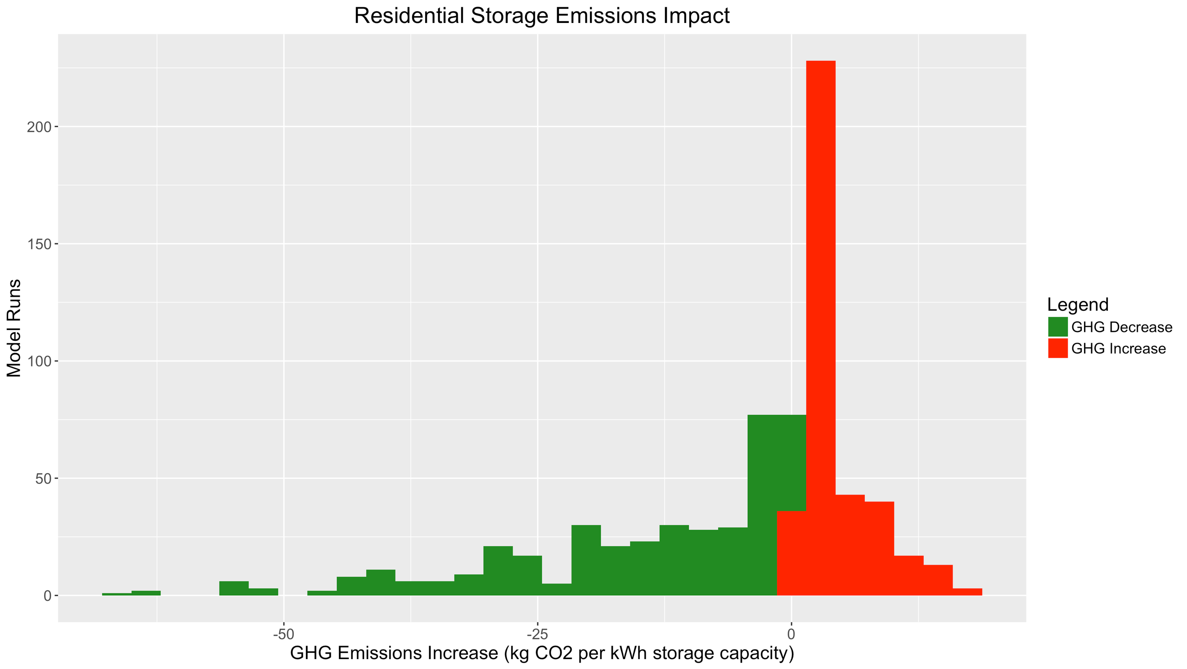

1. Impact of Load Profile and Rate Inputs

There is little difference in GHG impact between residential load profiles, although storage systems associated with the Central Valley PG&E profiles appear to have a lower GHG impact (fewer GHG-increasing model runs, and more GHG-reducing model runs) than the other profiles. This may be because the original load profiles have greater energy consumption during high-emissions peak-TOU-rate hours, and greater energy consumption in general, leading to greater utilization of the battery.

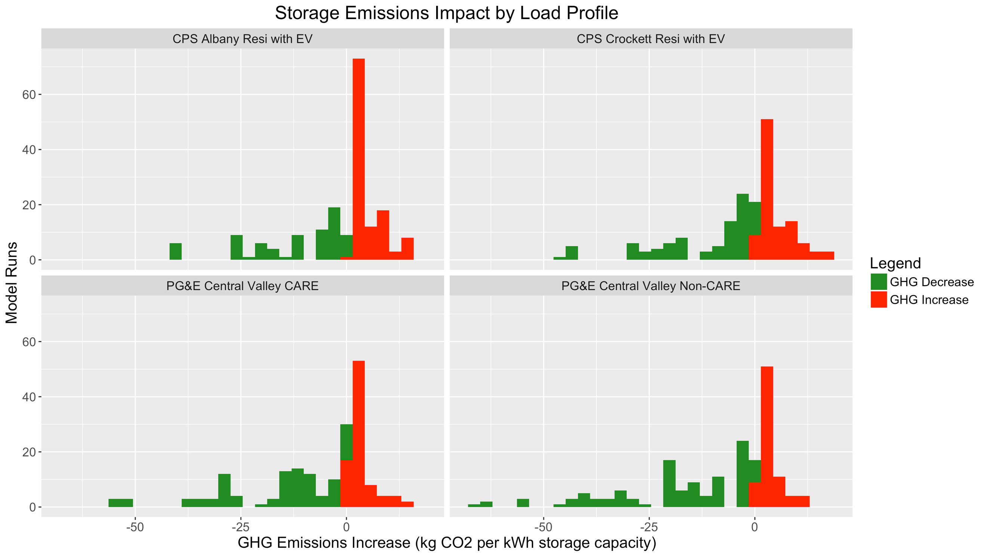

The impact of retail rates on GHG emissions is somewhat more significant. As the results below show, the majority of model runs with the PG&E E-1 tiered rate input cause an annual increase in GHG emissions. The majority of systems on the SDG&E DR-SES rate reduce GHG emissions, but there are a still a significant number of GHG-increasing systems on that rate.

The addition of the SmartRate critical peak pricing program to the E-1 rate results in a small decrease in annual GHG emissions impact. These SmartRate events (between 9 and 15 per year) tend to be fairly well-correlated with times of high marginal emissions, so this financial incentive to avoid charging and encourage discharging during SmartRate events improves emissions impacts slightly. Note that the impact on marginal generation, distribution, and transmission capacity costs from SmartRate and other similar programs may be much greater than the modest impact on GHG emissions shown here. While not detailed in this report, preliminary investigations using capacity costs provided by PG&E showed significant beneficial impacts on marginal costs from SmartRate, especially for Divisions where marginal distribution costs are higher than average.

Finally, the vast majority of storage systems on the proposed PG&E EV-A rate reduce emissions, with very few model runs reporting emissions increases. This TOU rate is effective in decreasing the magnitude of emissions increases, or increasing the magnitude of emissions decreases, because the rate’s low-price (off-peak or super-off-peak) hours tend to fall during low-emissions-rate times, and high-price peak hours tend to be correlated with high-emissions times. Moreover, the EV-A rate has sufficient differential between on-peak and off-peak costs to incent daily cycling, even in the winter. Newer TOU rates, with mid-day super-off-peak periods and later on-peak periods, are more effective in this regard than older TOU rates with higher mid-day prices and lower evening prices, as long as there is a sufficiently-large differential between peak and off-peak rates.

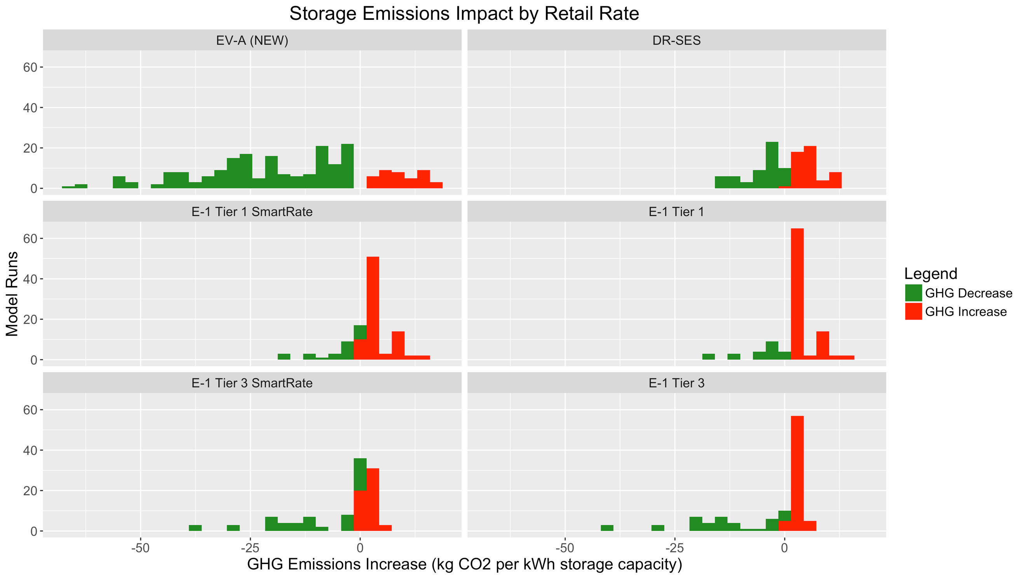

1. Impact of Solar and Storage Parameter Sensitivities

Residential solar-plus-storage systems appear to be more likely to reduce GHG emissions than storage-only systems. Note that storage-only and solar-plus-storage GHG emissions impacts are both evaluated using the same methodology: the storage system’s charge-discharge profile is multiplied by the marginal emissions rate in each timestep, and then these emissions impacts in each timestep are totaled to calculate annual GHG impact. Under this approach, the GHG emissions impact of the PV system itself is not included as part of the solar-plus-storage emissions impact. This also means that when storage systems charge “from solar” to receive the Investment Tax Credit, this charging is assigned the marginal grid emissions rate at that time, and not the solar’s 0-tons-per-kWh emissions rate. No adjustments are made to account for the avoided transmission and distribution losses associated with charging from paired solar as opposed to charging from the grid.

Solar-plus-storage systems tend to be associated with lower emissions because they are charging primarily in the middle of the day, when the solar PV system is producing. These times also happen to line up with times when utility-scale solar and other rooftop solar systems are producing, and systemwide net load (along with marginal GHG emissions rates) tends to be lowest.

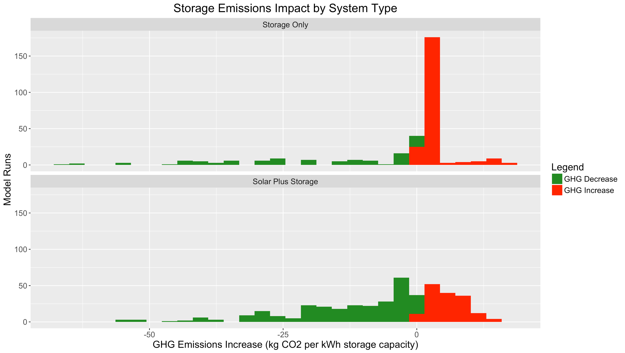

As modeled, lithium-ion battery storage systems are associated with slightly lower GHG emissions than flow batteries. This is primarily due to the use of both 85% and 70% single-cycle round-trip efficiency values for lithium-ion batteries versus a 70% round-trip efficiency value for flow batteries. Other differences between the two technologies, as modeled, include flow batteries’ 3-hour duration and their lack of a cycling penalty.

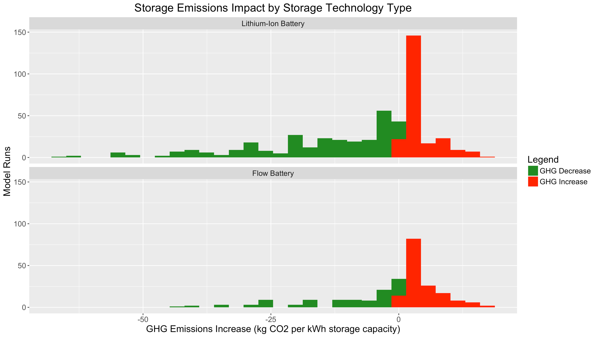

All other things being equal, systems with a lower single-cycle RTE are associated with higher emissions rates. With 85% single-cycle RTE, the majority (73%) of modeled residential storage systems reduced emissions. With 70% single-cycle RTE, only about 40% of modeled storage systems reduced emissions.

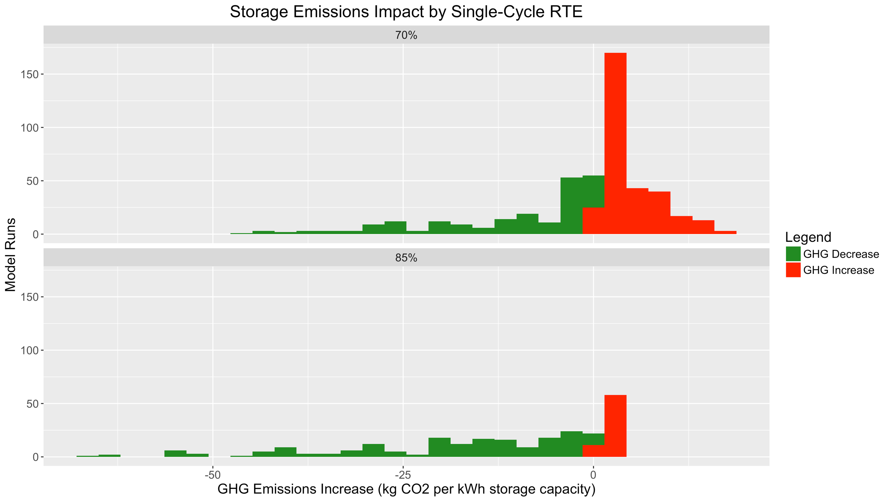

Another interesting comparison for residential storage systems is between the default Economic Dispatch storage control algorithm and the augmented Non-Economic Solar Self-Supply algorithm. The Solar Self-Supply algorithm only applies to solar-plus-storage systems on a non-TOU rate, such as the PG&E E-1 tiered rate, where the customer is performing non-economic solar self-consumption. Even though the systems are not responding to time-of-use rates, their charging during solar peak hours and discharging during evening hours results in a similar GHG impact to systems performing economic dispatch on updated TOU rates.

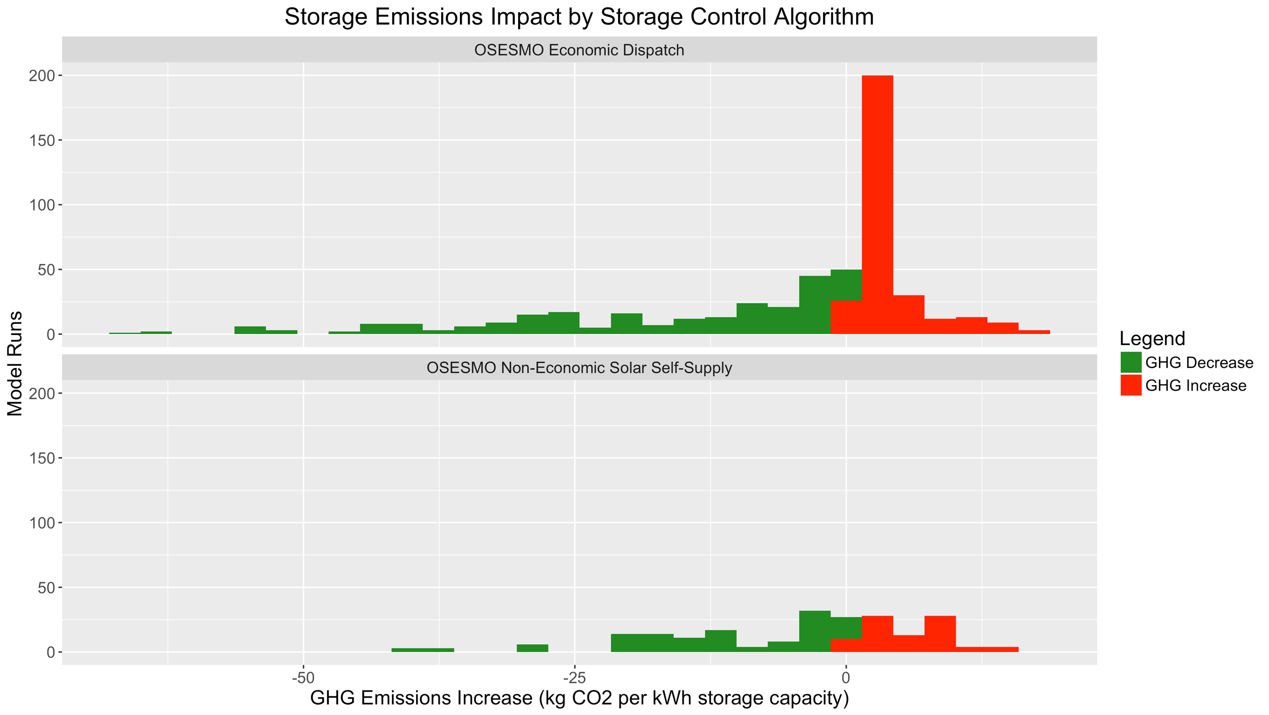

1. Impact of GHG Solutions

There is a noticeable difference in GHG emissions impacts among the four modeled GHG Solutions. Compared to the No GHG Emissions base-case, both the No-Charging Time Constraint and the Charging and Discharging Time Constraints are minimally effective in reducing emissions. On the other hand, GHG Signal Co-Optimization has a significant impact on GHG emissions relative to the base case. However, a sizable fraction of model runs under the GHG Signal Co-Optimization case are still increasing emissions. These GHG-increasing systems are primarily storage systems on tiered rates that do not cycle frequently, and therefore are not significantly affected by the GHG signal.

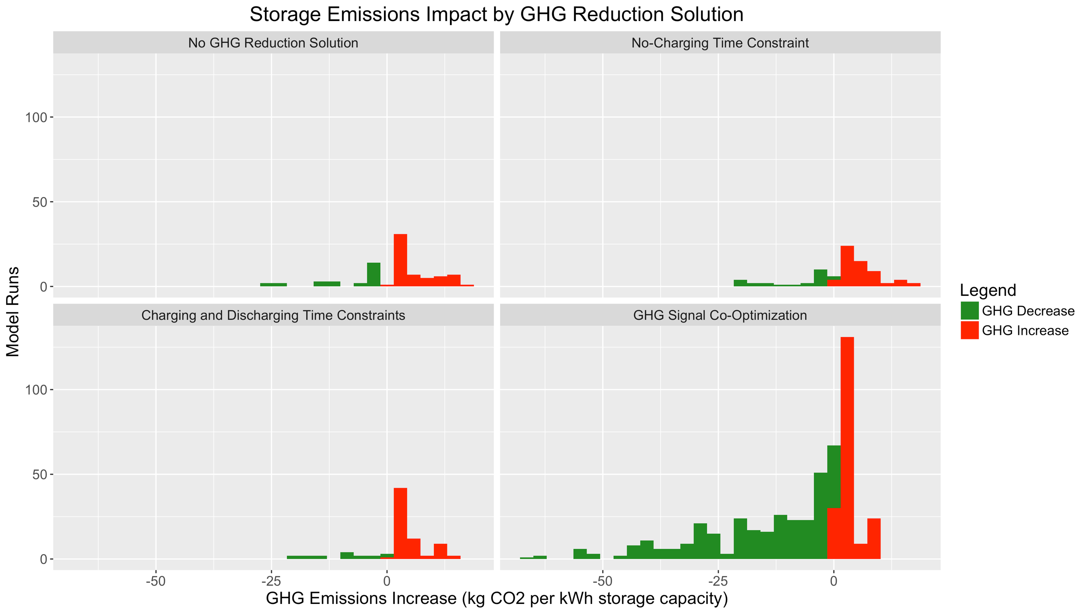

One interesting finding when looking at GHG Signal Co-Optimization cases is that the magnitude of the carbon adder used to convert GHG rates into an economic signal ($1/metric ton, $15/metric ton, or $65/metric ton) has little impact on its effectiveness at reducing emissions. This may be because the main impact of GHG Signal Co-Optimization is to change the storage system’s charge/discharge timing, rather than the amount of charging and discharging. On residential rates, the addition of a GHG signal encourages the storage system to charge during the lowest-emissions time periods of a particular off-peak TOU period, and to discharge during the highest-emissions time periods of a particular on-peak TOU period. Much higher carbon adders might be necessary to change the amount of charging/discharging, given the impact of charge cycles on battery life, and the cost of round-trip-efficiency losses.

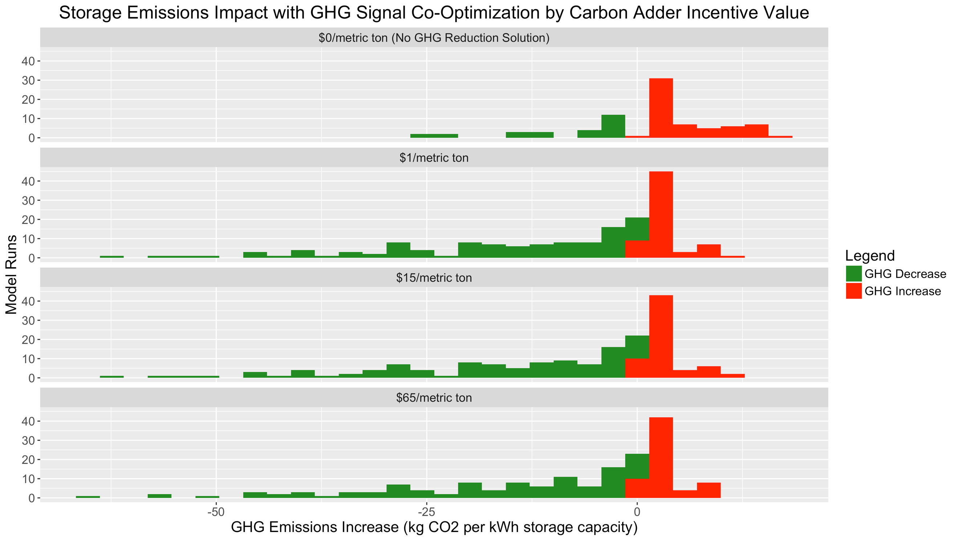

Another item to note is that although there is some difference between the perfect-information Real-Time Five-Minute emissions signal and the imperfect Day-Ahead WattTime-public-model emissions signal, the day-ahead GHG forecast signal is still effective at reducing emissions. It should be noted that this day-ahead forecast represents a lower bound on forecast accuracy, because an operational storage system would be able to receive a rolling forecast that can predict emissions rates for the next few hours more accurately than the prior day’s day-ahead forecast.

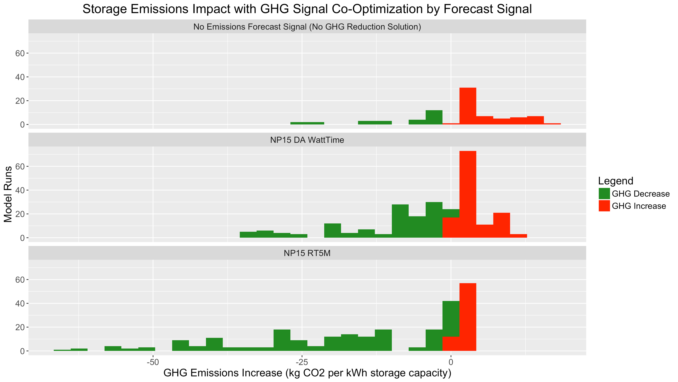

GHG emissions impacts can also be visualized with combinations of residential retail rates and GHG Reduction Solutions. On the PG&E E-1 rate, the majority of model runs are associated with increased GHG emissions. This is true even with GHG Signal Co-Optimization, although co-optimization does help reduce emissions in many cases. Note that the results below include both the standard version of PG&E E-1 as well as E-1 with SmartRate.

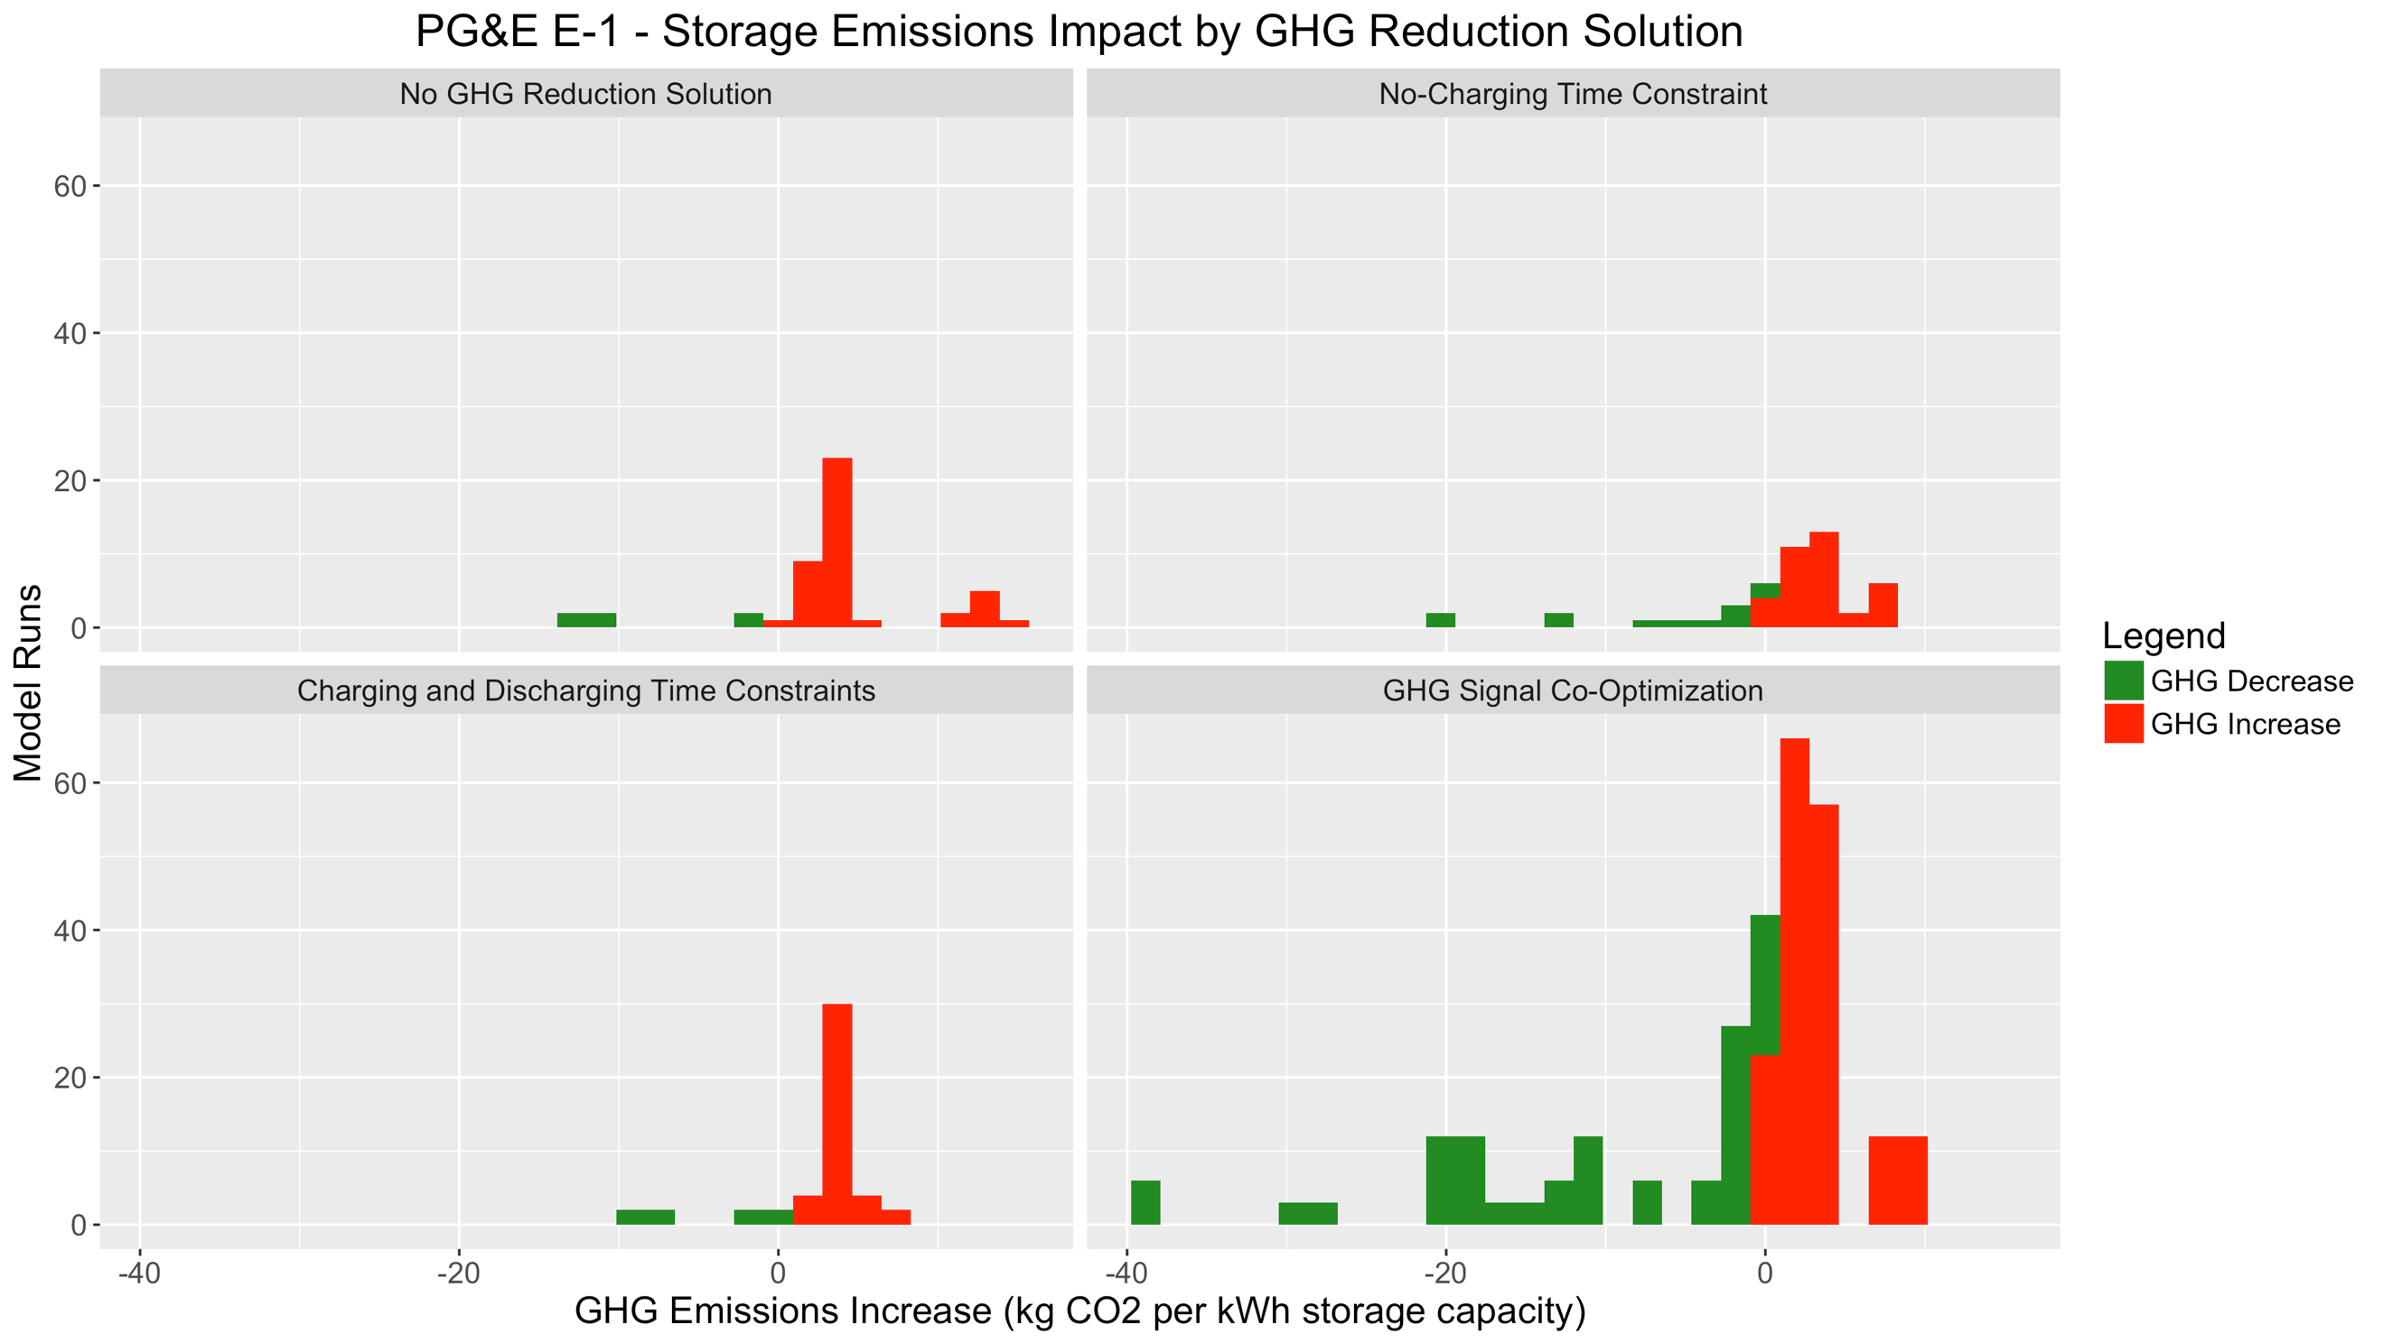

Under the SDG&E DR-SES rate, the majority of model runs under the No GHG Solution base case and the Time-Constraint cases result in increased emissions. However, the majority of DR-SES model runs with GHG Signal Co-Optimization reduce emissions.

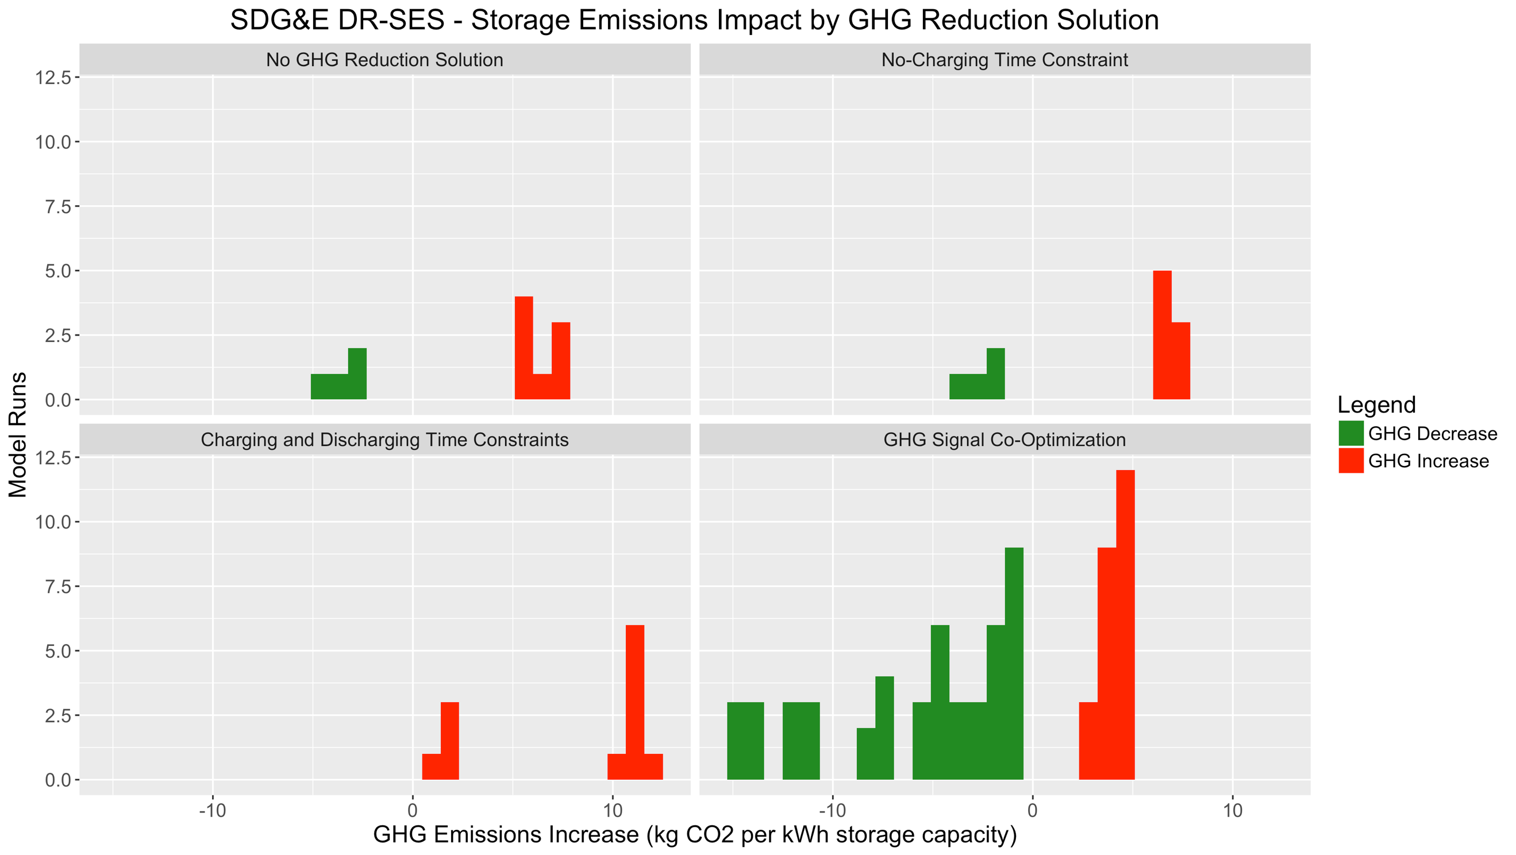

Finally, under the PG&E EV-A rate, the majority of model runs are associated with reduced emissions even for the No GHG Reduction Solution base case. Furthermore, when the GHG Signal is added, all of the model runs reduce emissions, and none increase emissions.

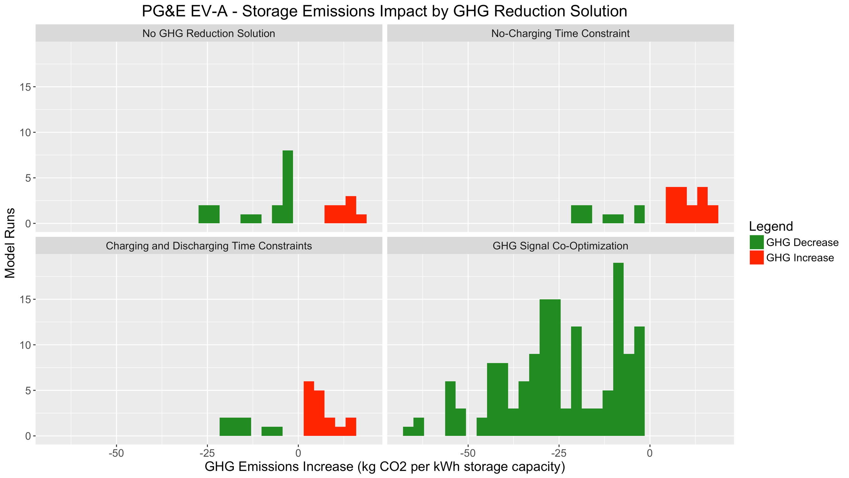

*B. Commercial & Industrial Storage Modeling Results*

First, 1447 model runs were performed to determine the best storage system size for each combination of load profile, system type (storage-only versus solar-plus-storage), storage type (lithium-ion vs. flow battery), and retail rate. Only the No GHG Solution base case was modeled when determining sizing. Then, 2754 model runs were performed using the selected system sizes, to evaluate the impact of the three GHG solutions. A distribution of GHG impacts across all commercial & industrial model runs for the selected storage sizes can be seen below.

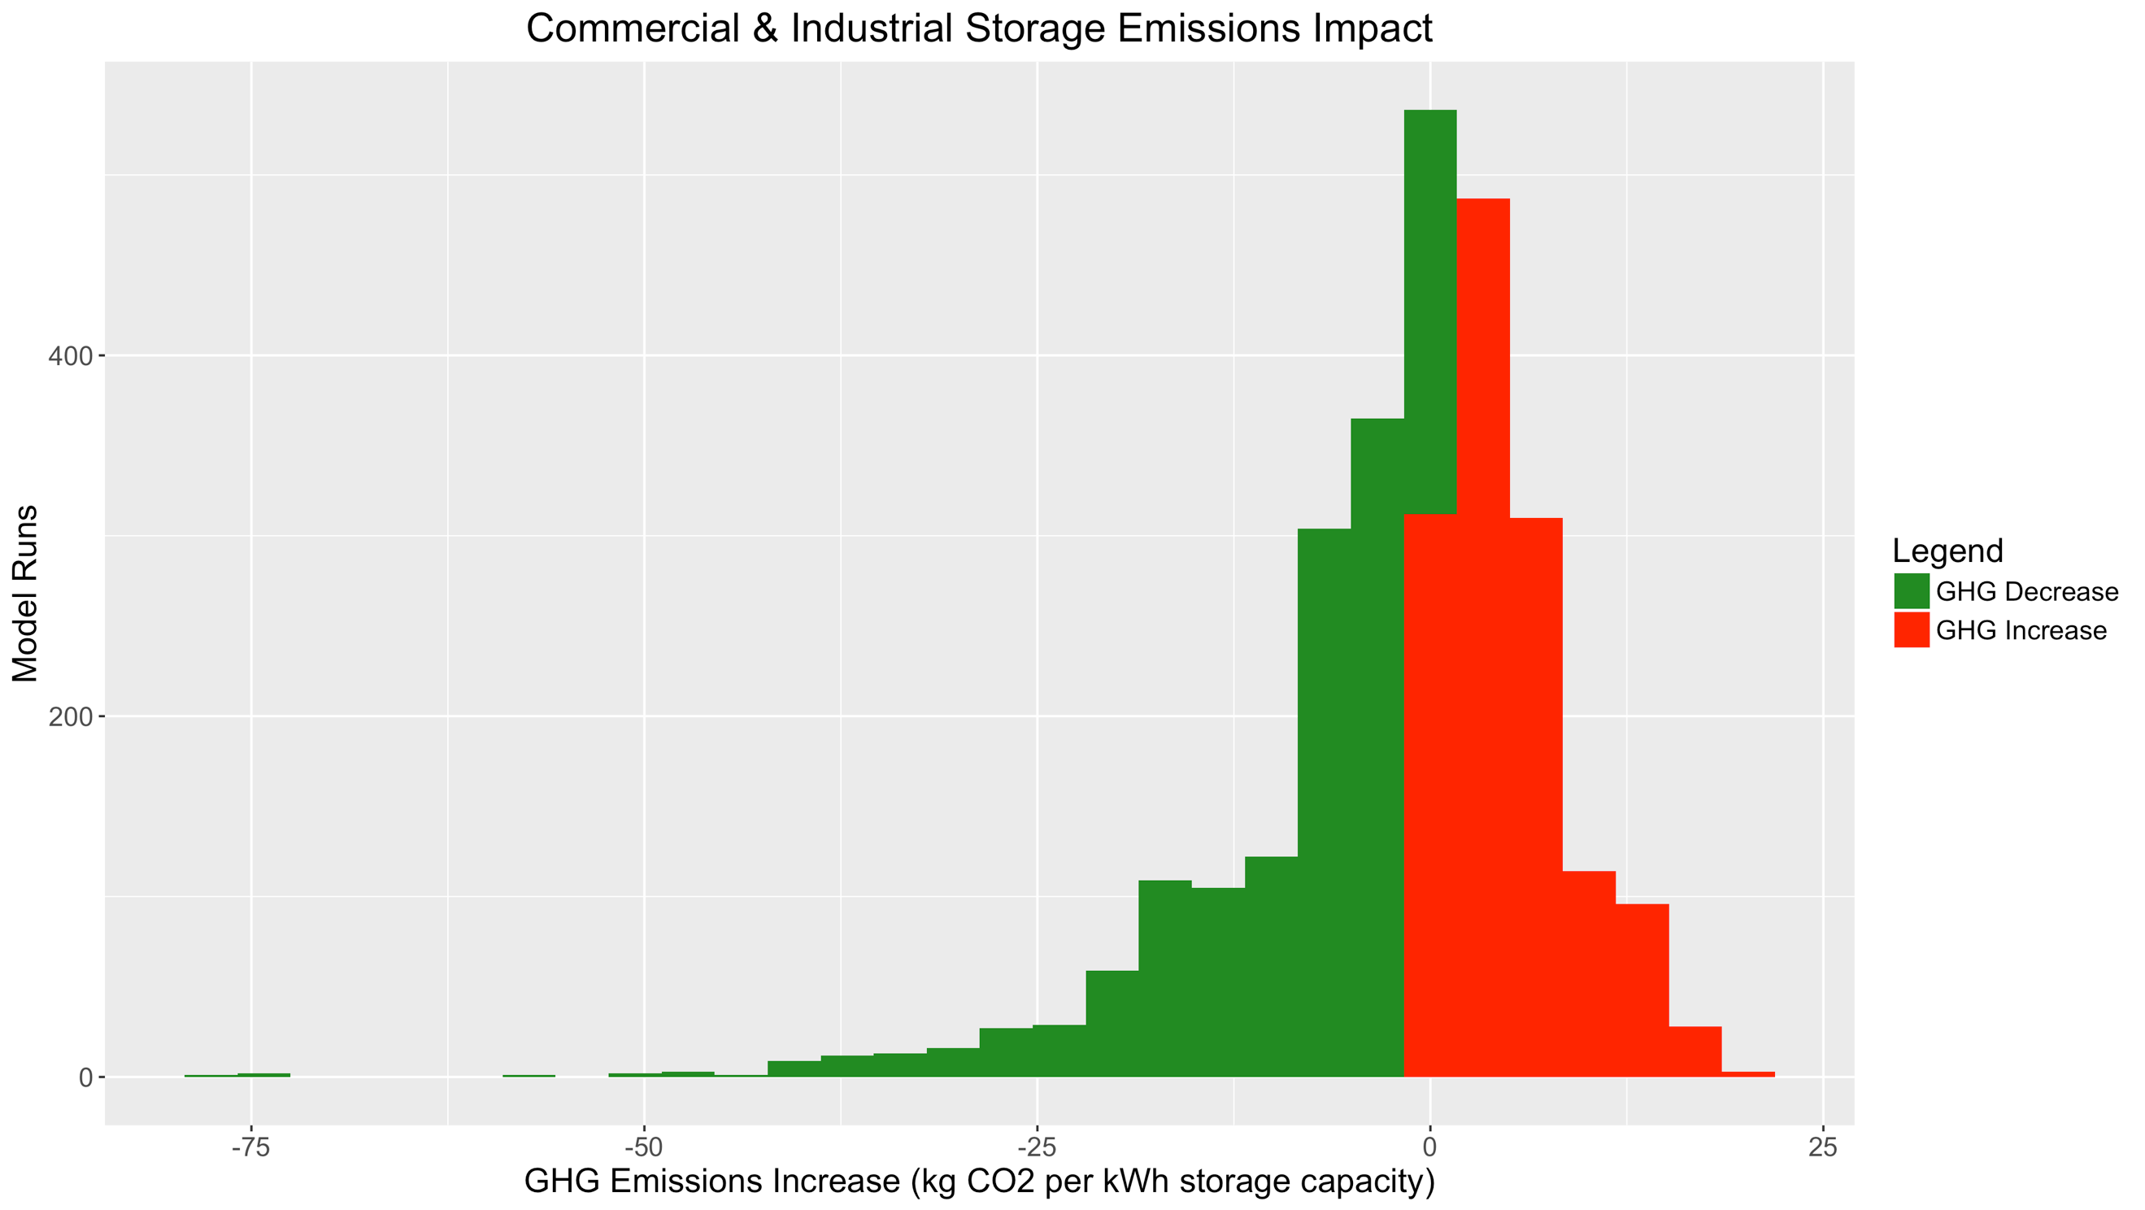

1. Impact of Load Profile and Rate Inputs

There is substantially more diversity in GHG impacts between load profiles for commercial & industrial load profiles compared to residential load profiles. This is likely due to the existence of a noncoincident demand-charge value stream that encourages reducing the customer’s maximum demand. If the customer’s maximum demand tends to fall during high-emissions evening peak hours, the storage system will frequently be discharging during these periods and reducing GHG emissions. Conversely, if the site’s maximum demand falls during mid-day hours, the storage system will tend to discharge at low-emissions times, increasing GHG emissions.

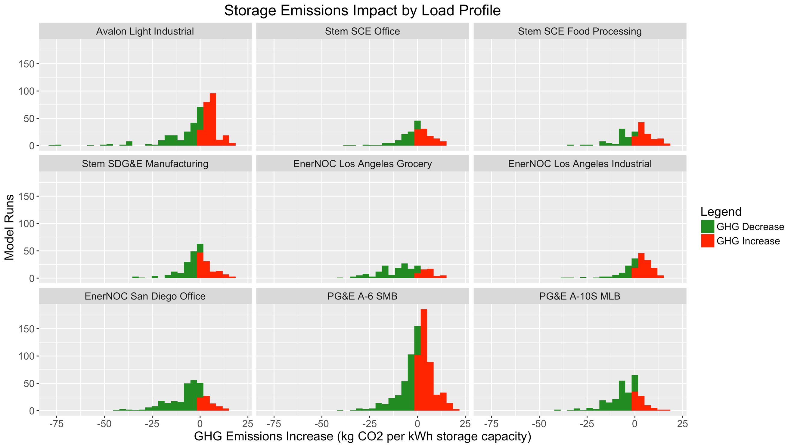

As with residential storage systems, retail rates significantly influence commercial & industrial storage systems’ GHG impacts. Generally, new rates with updated TOU periods are associated with lower GHG emissions than older rates. Systems on Option R rates (which are exclusive to customers with solar) tend to have lower emissions than their default-rate counterparts; however, this result is likely primarily associated with ITC-compliant midday solar charging by solar-plus-storage systems, as opposed to the rate structure itself. Critical Peak Pricing and Peak Day Pricing rates only have a very slight impact on GHG emissions, likely because these events occurred only 3-15 times in 2017 (depending on the utility). Much as with the residential SmartRate, CPP and PDP rates appear to have a more significant beneficial impact on utility marginal capacity costs.

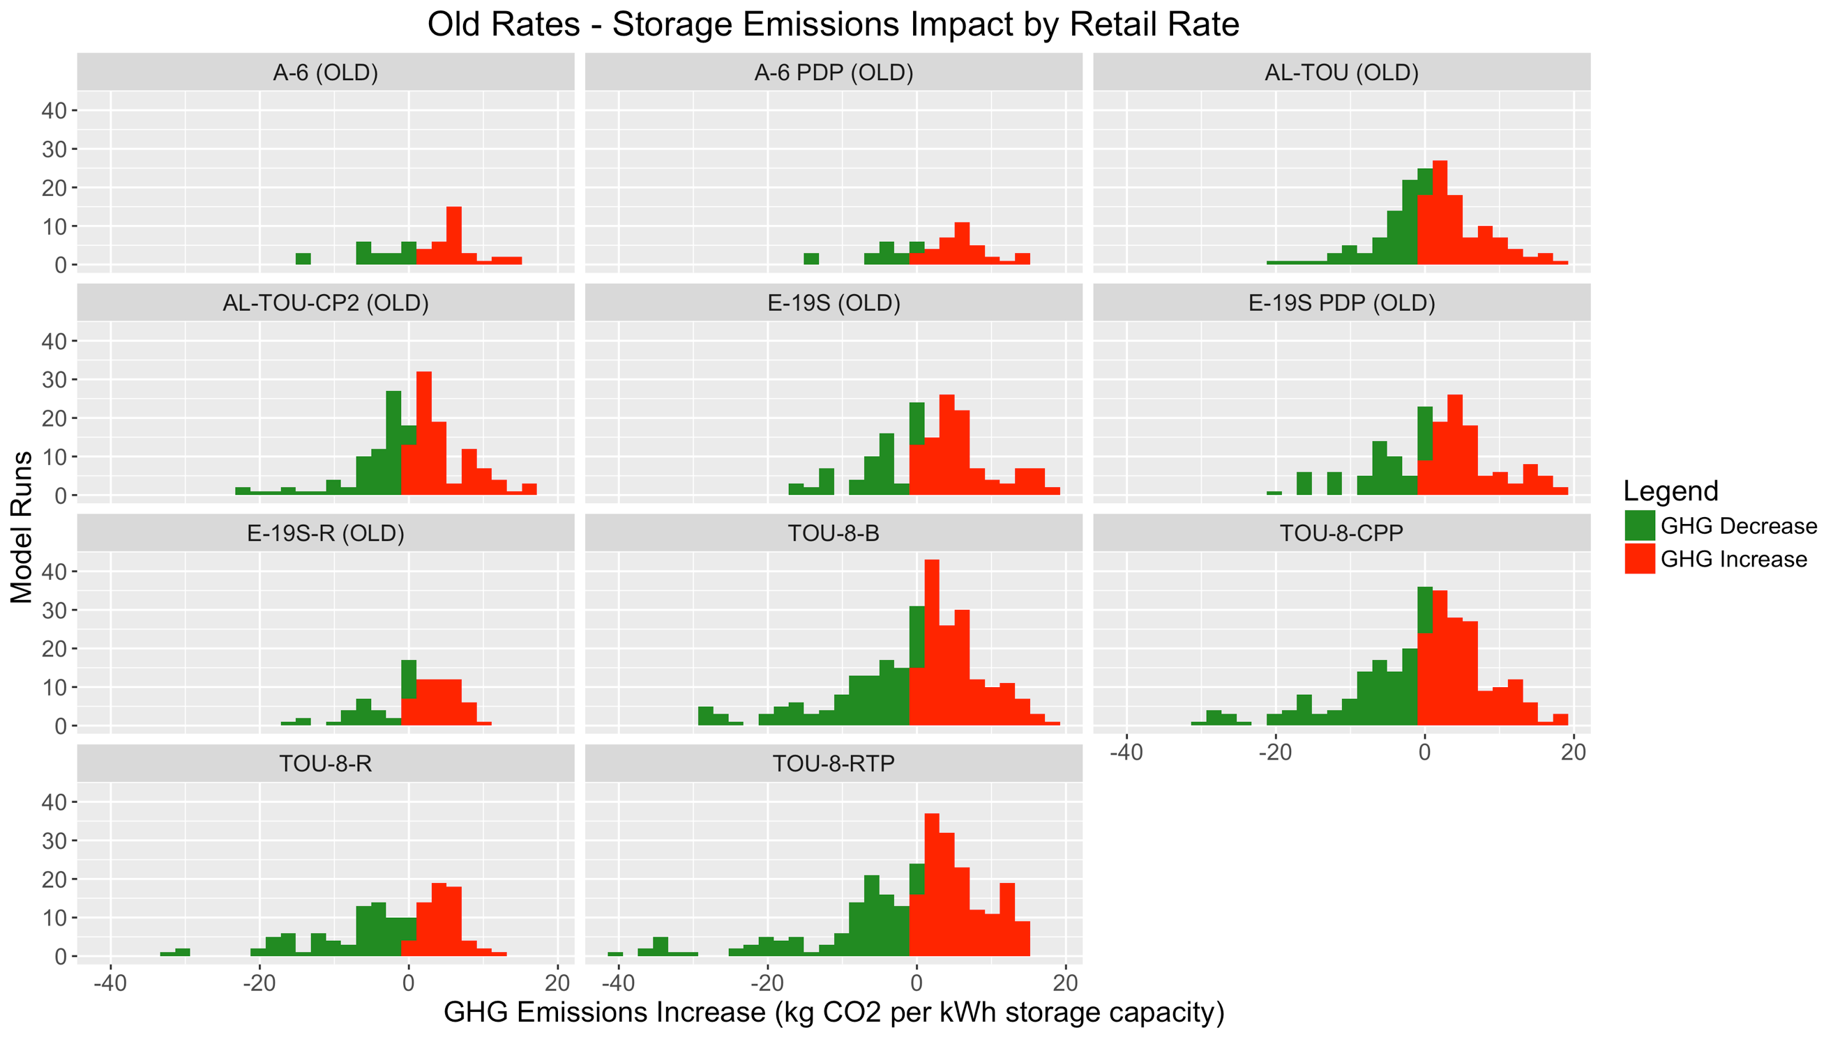

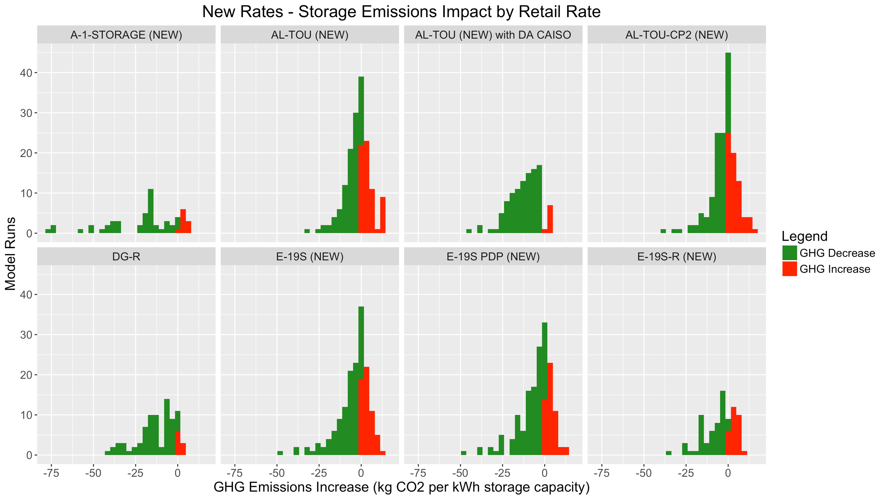

One interesting point of comparison can be drawn between SCE’s current TOU-8-RTP (OLD) rate, and the hypothetical SDG&E AL-TOU with Day Ahead CAISO (NEW) rate structure. The SCE TOU-8-RTP (OLD) rate modeled is the current version of the rate, and not the proposed rate from the SCE General Rate Case. Much like some of the older TOU rates, its daily price profile does not match up with current net demand, wholesale price, and marginal emissions rate profiles.

In addition, this “real-time pricing” rate is based on the previous day’s maximum temperature, and so it is only reflective of grid conditions when temperatures and system-level demand are similar to the prior day’s. On the other hand, the hypothetical AL-TOU with Day-Ahead CAISO rate directly reflects (predicted) grid conditions, and therefore does not feature this misalignment. As a result, the difference in GHG impacts between the two rates is dramatic.

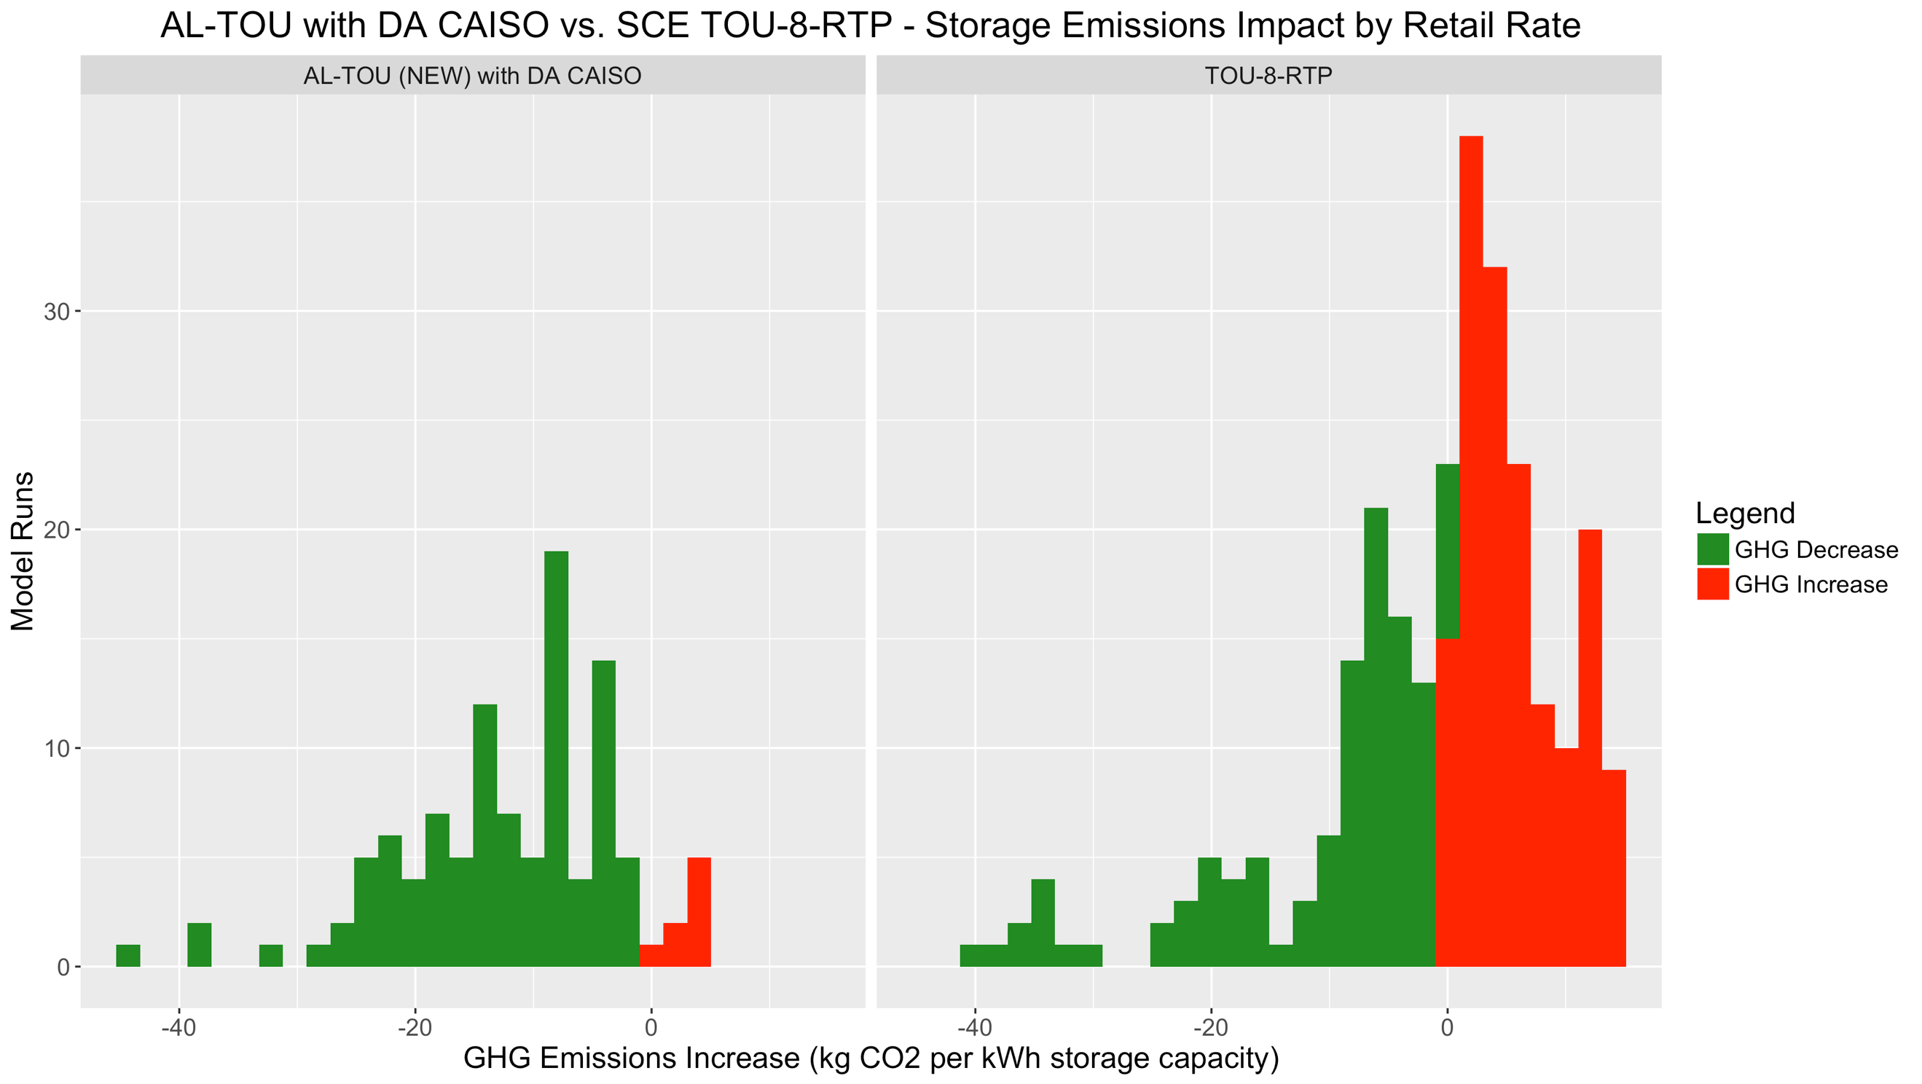

1. Impact of Storage Parameter Sensitivities

As with the residential models, commercial & industrial solar-plus-storage systems appear to be more likely to reduce GHG emissions than storage-only systems, because they tend to charge during low-emissions mid-day hours. It’s worth noting that this shift in charging patterns between standalone-storage and solar-plus-storage is primarily attributable to the Investment Tax Credit’s requirement that charging occur during solar production hours.

However, not all solar-plus-storage projects claim the ITC. Retrofits of existing solar projects with storage, and MUSH (municipal, university, school, hospital/nonprofit)-owned projects, may not be ITC-eligible. Such non-ITC solar-plus-storage projects would still be likely to have their maximum net demand occur later in the day, and noncoincident demand-charge reduction would therefore be primarily focused on high-emissions evening hours. As a result, they would be likely to see lower GHG emissions relative to standalone storage with the same load profile, but may be less GHG-reducing than solar-plus-storage systems that do claim the ITC and charge at least 75% from solar. In this modeling effort, all solar-plus-storage systems were assumed to be claiming the ITC and charging 100% from solar.

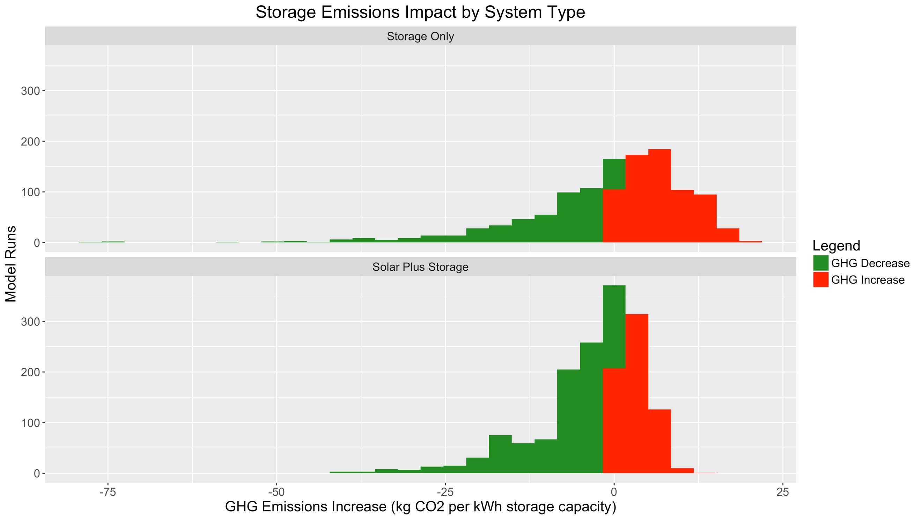

As modeled, lithium-ion battery storage systems are associated with slightly lower GHG emissions than flow batteries. Lithium-ion batteries were modeled with both 85% and 70% single-cycle round-trip efficiency values, but flow batteries were all modeled with 70% RTE. Flow batteries were also modeled as having a longer duration, and no cycling penalty. In addition, flow batteries have a slightly larger per-kWh cost, so it’s possible that smaller storage systems were selected based on the 8-year-simple-payback methodology. However, these additional differences are likely to be less significant than that of single-cycle RTE.

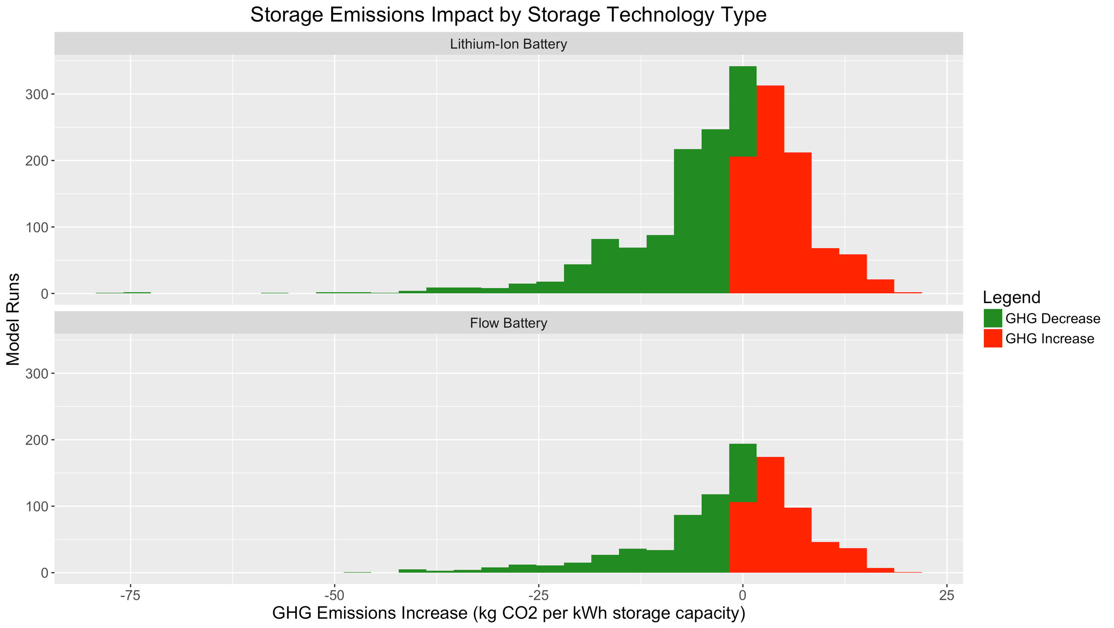

All other things being equal, systems with a lower single-cycle RTE are associated with higher emissions rates.

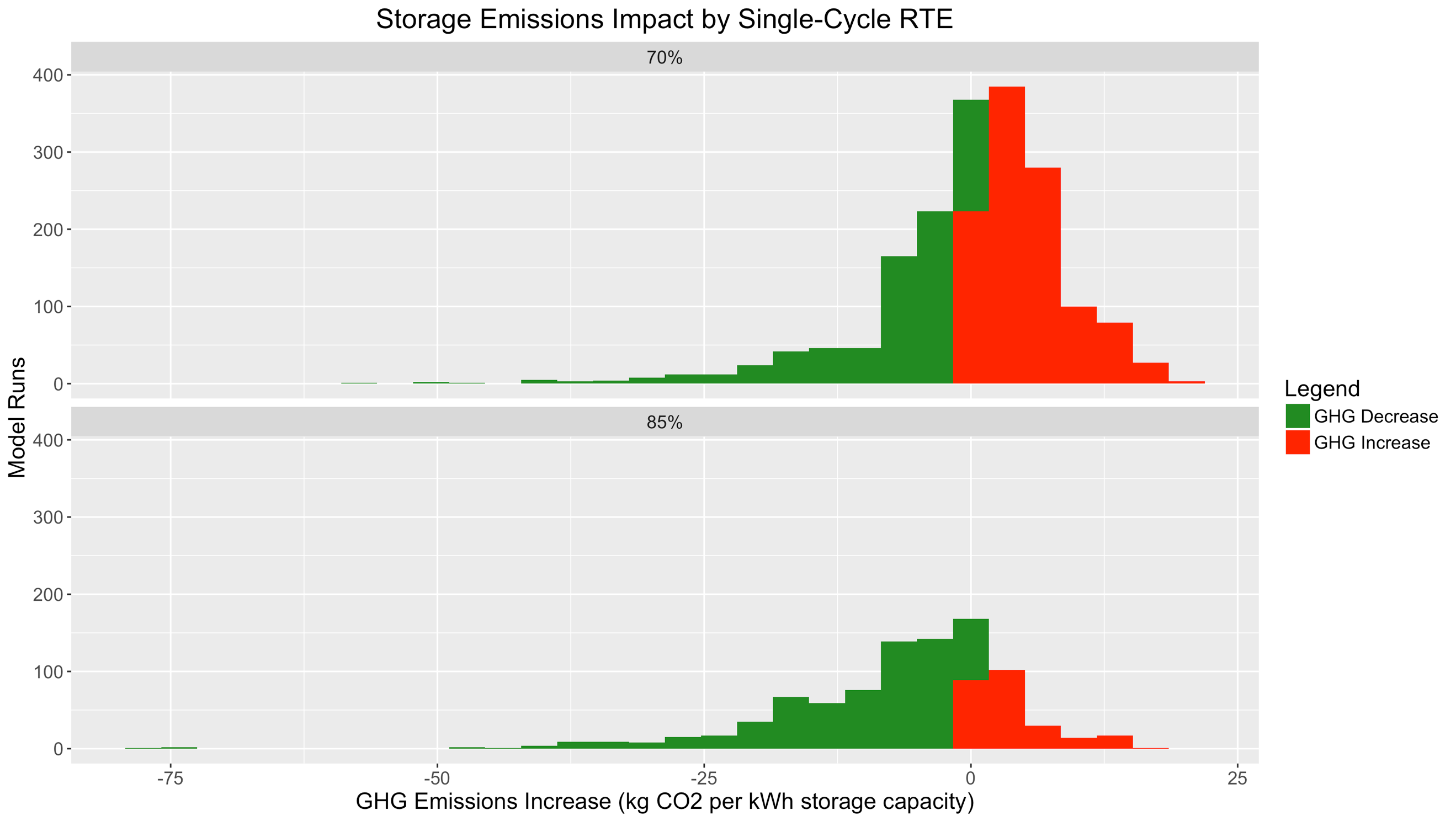

1. Impact of GHG Solutions

There is a noticeable difference in GHG emissions impacts among the four modeled GHG Solutions. Compared to the No GHG Emissions base-case, both the No-Charging Time Constraint and the Charging and Discharging Time Constraints are minimally effective in reducing emissions. On the other hand, GHG Signal Co-Optimization has a significant impact on GHG emissions relative to the base case. However, a large fraction of model runs under the GHG Signal Co-Optimization case are still increasing emissions. These GHG-increasing systems include commercial & industrial sites with noncoincident maximum demands that do not fall during high-GHG hours, or systems on older TOU rates with coincident-peak demand charges during midday hours and off-peak energy rates during evening hours.

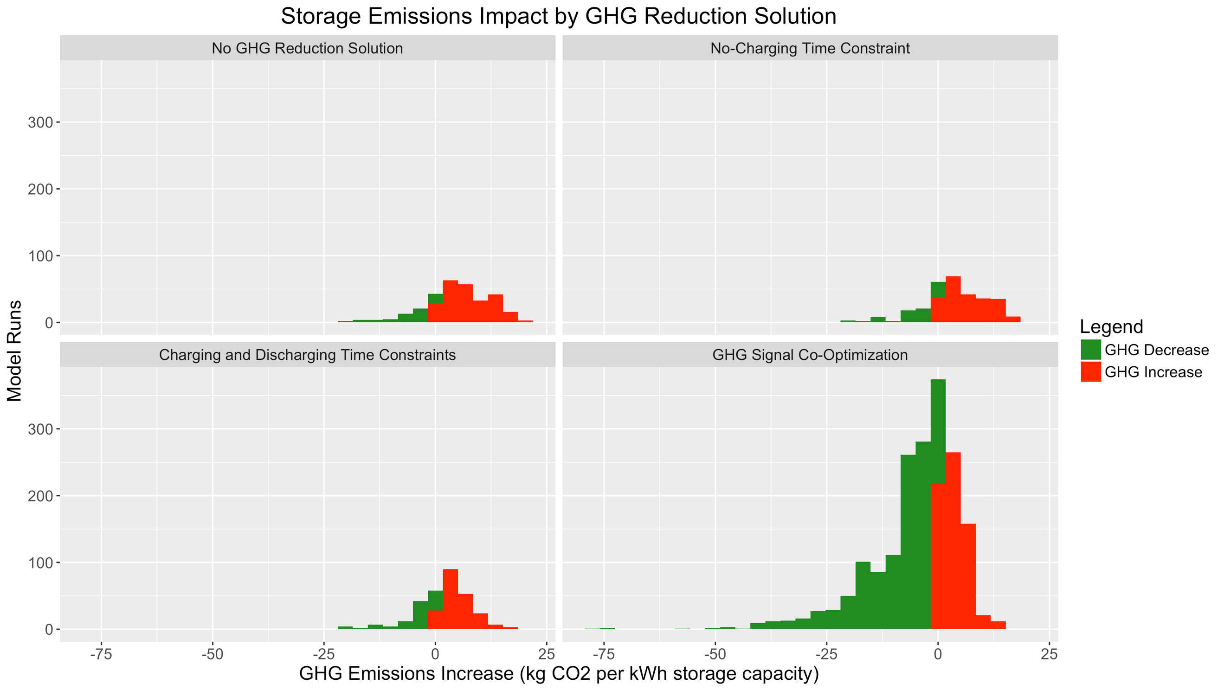

In contrast to the residential model runs, the magnitude of the carbon adder used to convert GHG rates into an economic signal ($1/metric ton, $15/metric ton, or $65/metric ton) has a small but noticeable impact on its effectiveness at reducing emissions. This may be because commercial & industrial rates have a more complex structure with multiple energy and demand charges. Residential storage charge/discharge patterns have a tendency to change as soon as a nonzero GHG-based economic signal is added to TOU energy rates, but then do not change significantly as the magnitude of the carbon adder is increased. By contrast, nonresidential storage charge/discharge patterns may change less when a small nonzero emissions signal is added, but continue to see incremental changes as the adder value is increased.

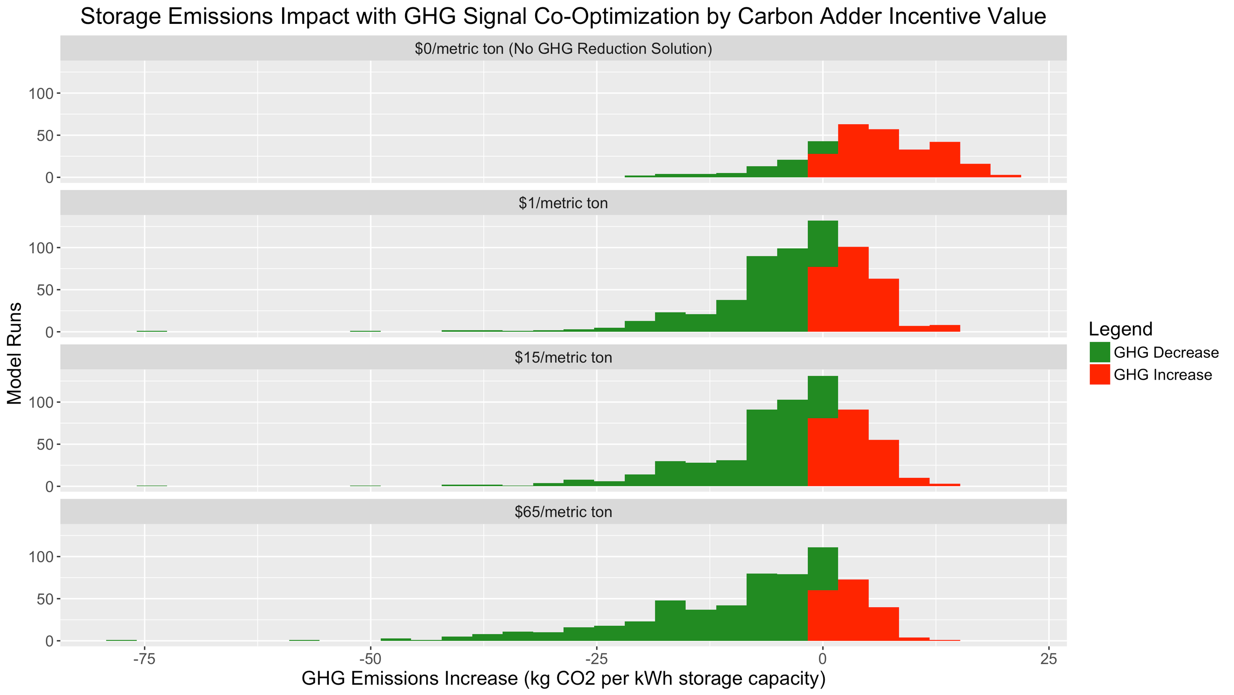

There is also a noticeable difference between GHG impacts using the perfect-information Real-Time Five-Minute emissions signal and the imperfect day-ahead WattTime-public-model emissions signal, although the day-ahead GHG forecast signal is still effective at reducing emissions relative to the base case. A rolling forecast that can accurately predict near-term GHG emissions impacts more accurately than the prior day’s day-ahead forecast is likely to be more effective at reducing emissions. Storage technology companies may be able to leverage their sophisticated load-forecasting algorithms for this purpose, even if a public rolling GHG forecast is not provided.

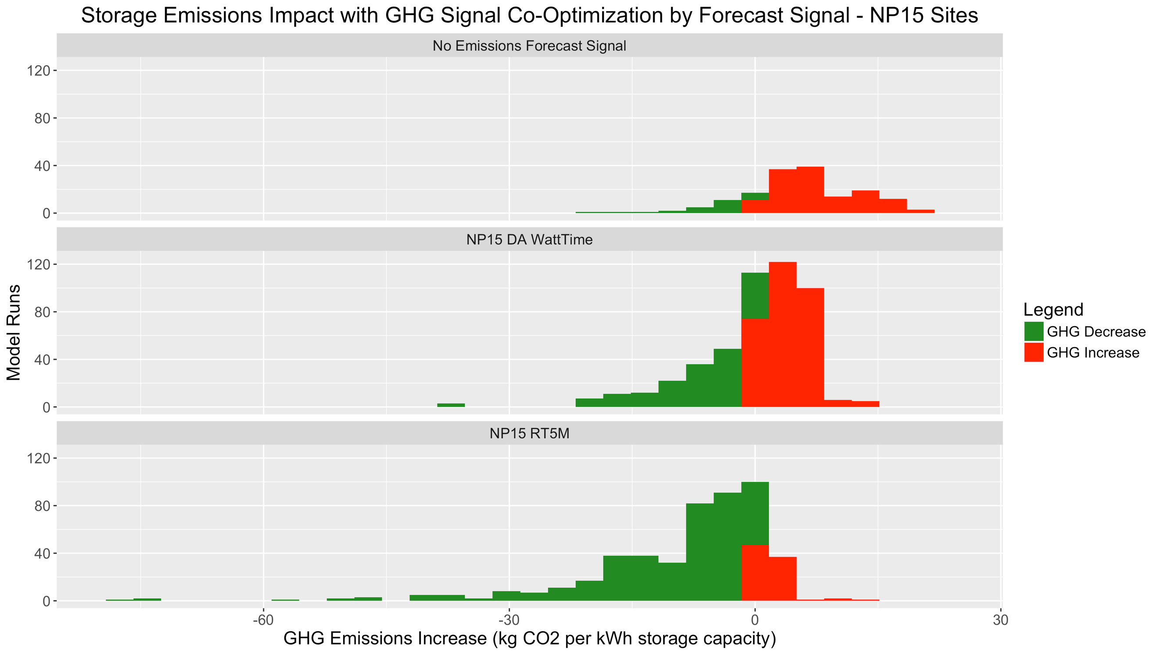

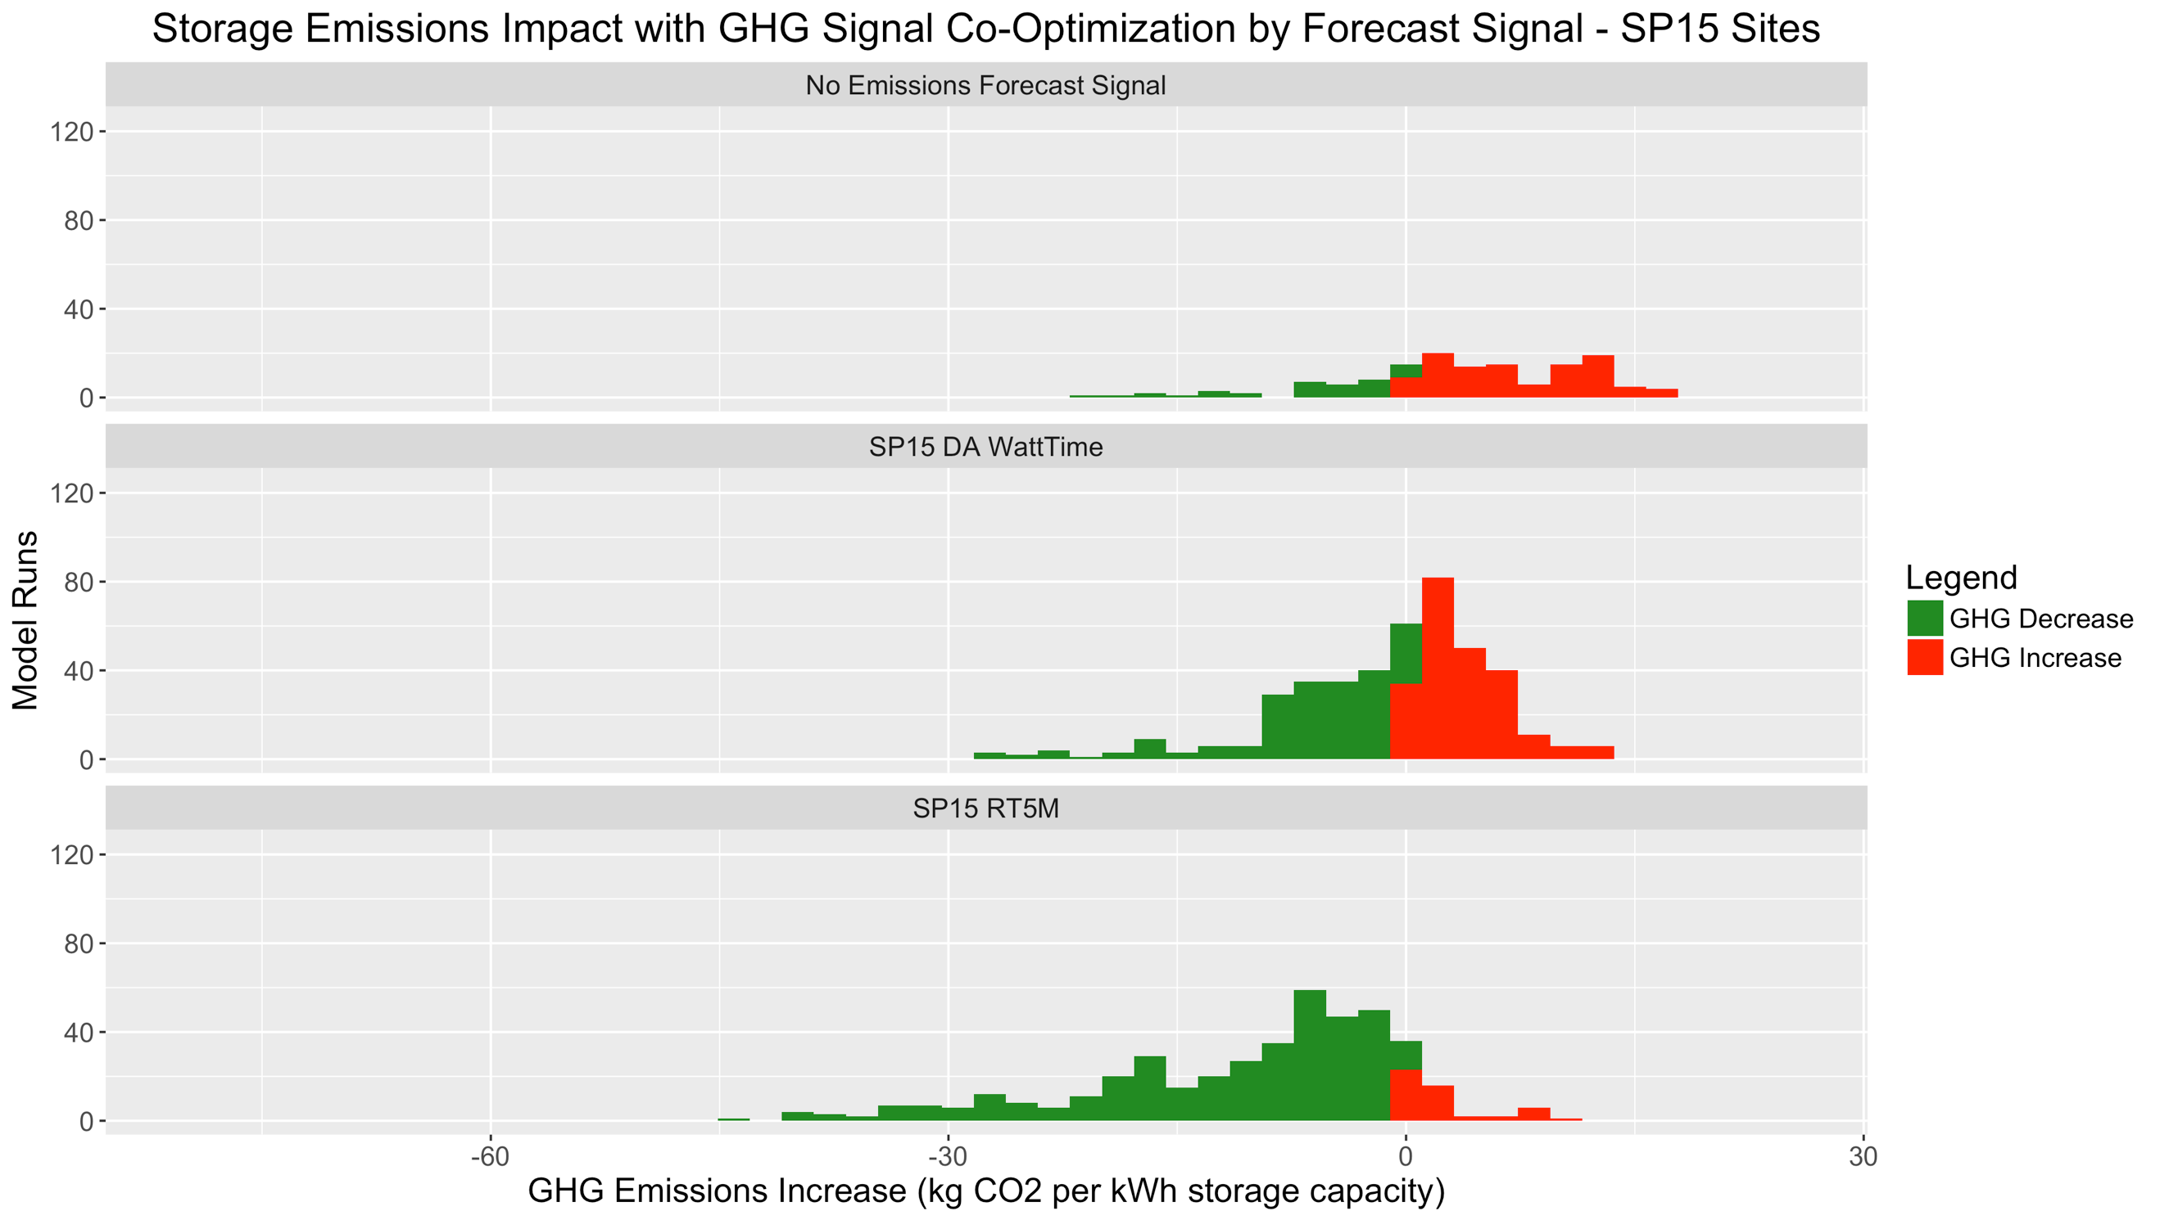

Finally, GHG emissions impacts can be visualized with combinations of commercial & industrial retail rates and GHG Reduction Solutions. For example, on the current PG&E E-19S (OLD) rate, the vast majority of model runs are associated with increased GHG emissions in the No GHG Solution and time-constraints cases. With GHG Signal Co-Optimization, the numbers of GHG-increasing and GHG-decreasing systems are roughly equal.

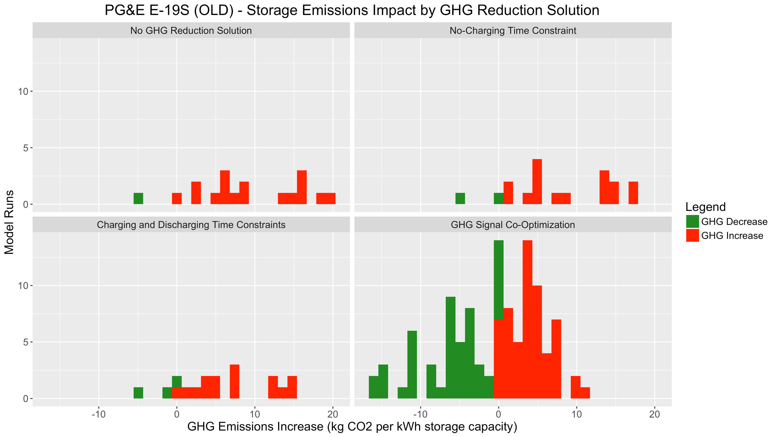

On the proposed PG&E E-19S (NEW) rate, the majority of model runs still show an increase in GHG emissions in the No GHG Solution case. However, after adding GHG Signal Co-Optimization, the majority of modeled storage systems are GHG-decreasing.

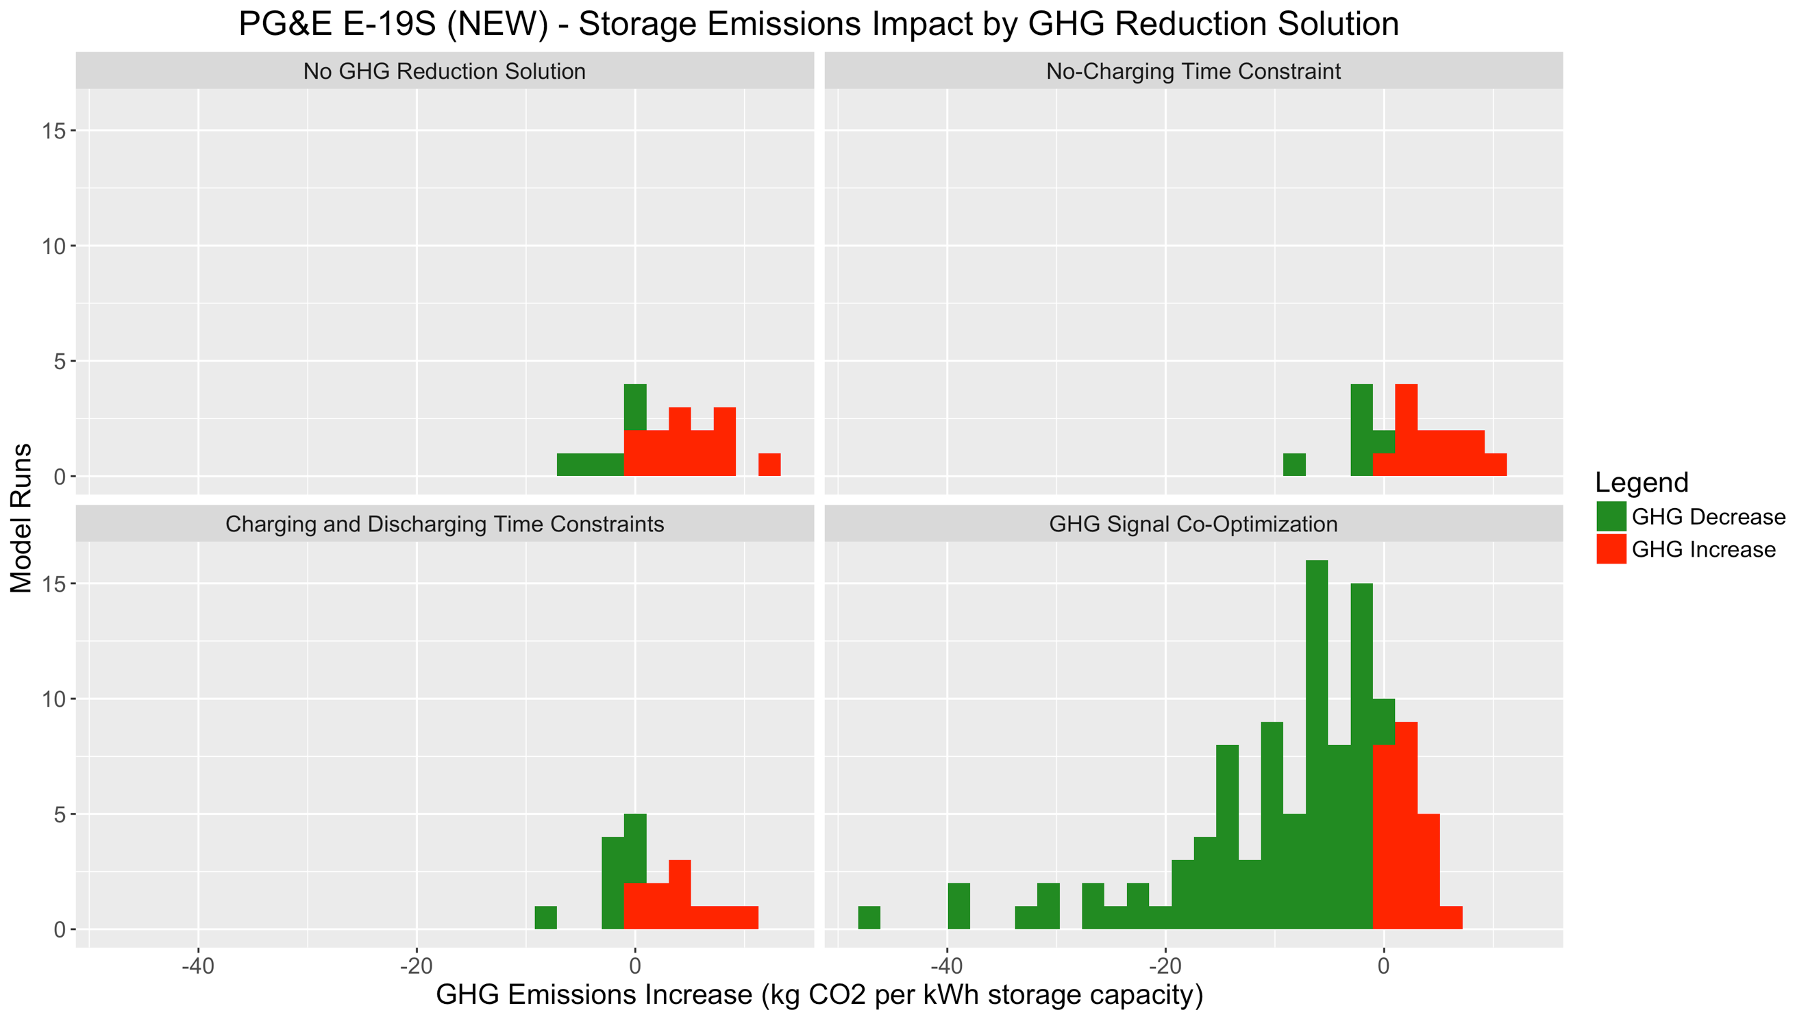

On the SCE TOU-8-B (OLD) rate, the majority of modeled systems are GHG-increasing. With GHG Signal Co-Optimization, the numbers of GHG-increasing and GHG-decreasing systems are roughly equal.

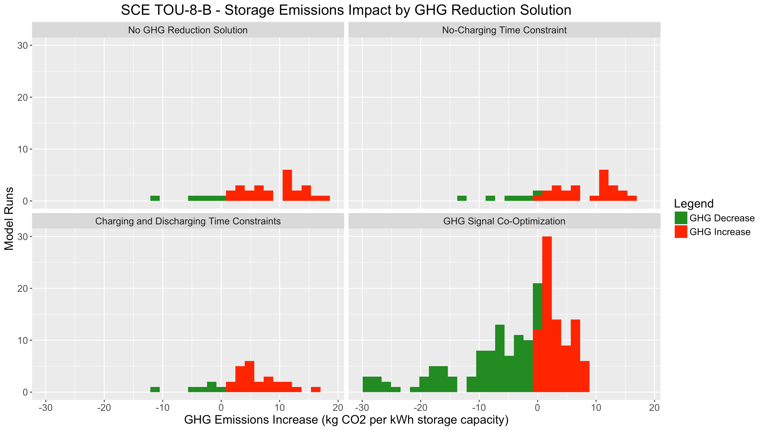

On the SCE TOU-8-R (OLD) rate (only for customers with PV), the majority of model runs still show an increase in GHG emissions in the No GHG Solution case. However, with GHG Signal Co-Optimization, the majority of modeled storage systems are GHG-decreasing. On this particular rate, the time-constrained cases do show more GHG reduction than the base case, though not nearly as much as the GHG Signal Co-Optimization cases.

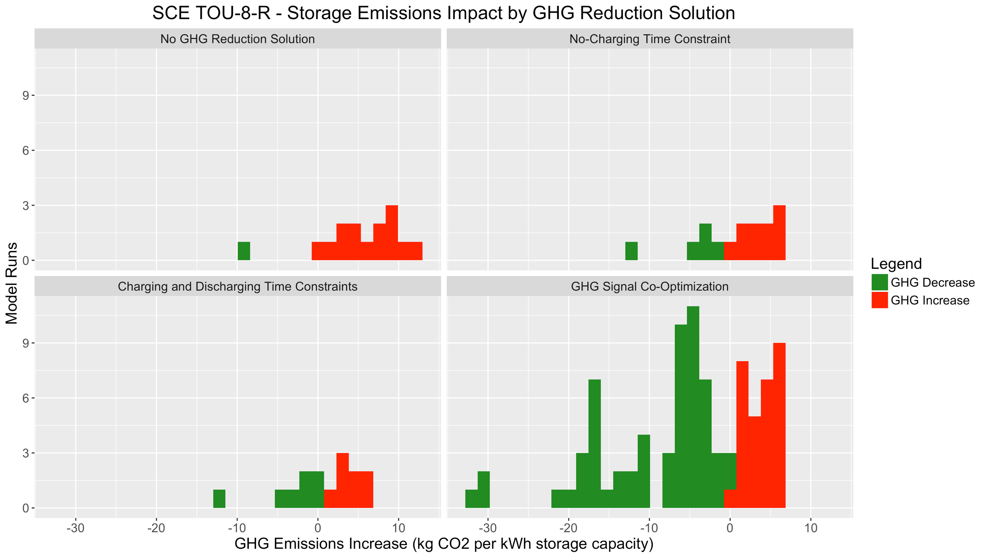

On the SDG&E AL-TOU (NEW) rate, a slight majority of model runs are GHG-increasing. After adding GHG Signal Co-Optimization, the majority of modeled storage systems are GHG-decreasing.

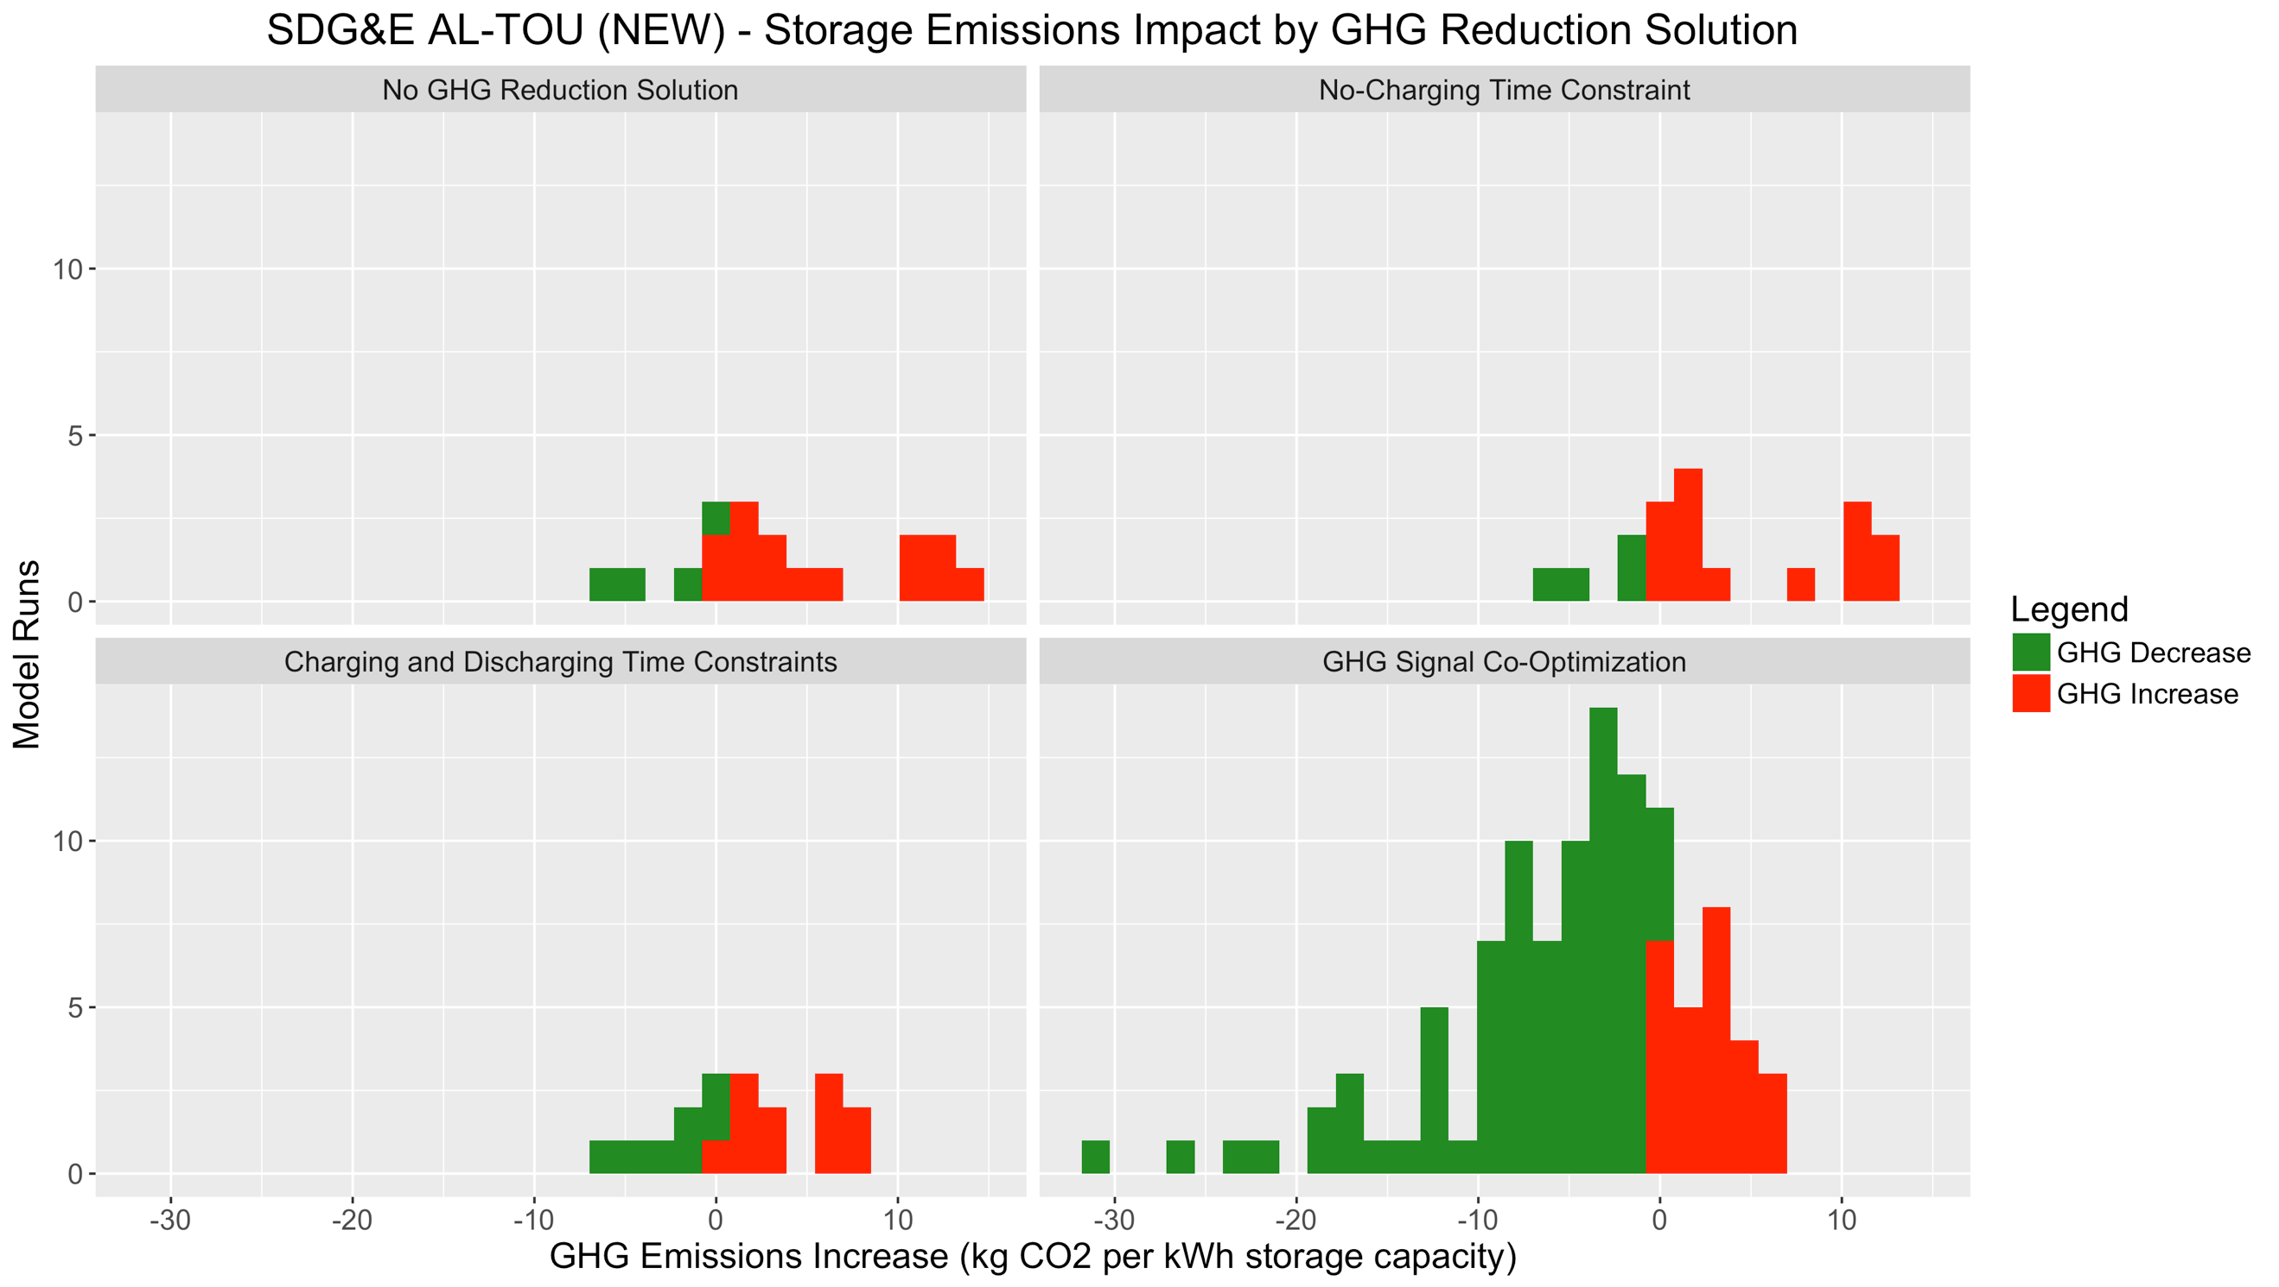

On the hypothetical SDG&E AL-TOU rate featuring Day-Ahead CAISO energy prices in place of the EECC TOU energy rates, nearly all modeled systems are GHG-reducing, across all four GHG Solutions. This is because the Day-Ahead CAISO energy prices are very similar to the WattTime Day-Ahead GHG emissions forecast.

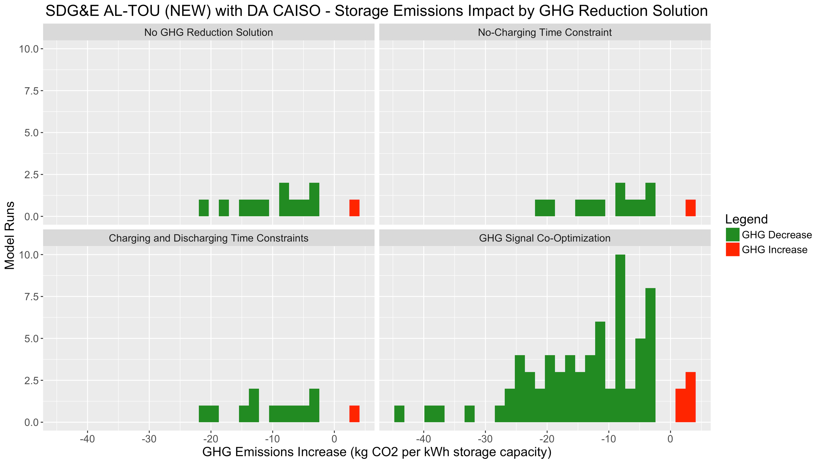

V. CONCLUSIONS

The results above allow a number of conclusions to be drawn to help inform the Working Group’s recommended modifications to SGIP eligibility requirements and incentive structures:

First, the results suggest that out-of-date retail rate structures that are poorly aligned with real-time grid conditions and GHG emissions are a key driver of behind-the-meter energy storage systems’ tendency to increase emissions.

For residential storage systems, this includes the use of non-time-of-use tiered rates, as well as TOU periods featuring high energy rates during peak solar-production hours and lower energy rates during high-emissions evening hours. Recent and upcoming TOU rates are better aligned with average daily cost and emissions profiles, and modeling results suggest that storage systems operating to minimize bills for customers on these rates are more successful at reducing GHG emissions, especially when paired with solar and taking the ITC.

For commercial & industrial customers, older rates also tend to feature out-of-date TOU periods, as well as a greater emphasis on of noncoincident demand charges. If the customer’s maximum demand occurs during low-emissions mid-day hours (which is common for commercial & industrial customers, but uncommon among residential customers), storage systems will be strongly incentivized to discharge during those hours, and will potentially charge during evening hours at high emissions rates if energy rates are low during these times. Updated commercial & industrial rates feature higher energy costs during evening hours and low Super-Off-Peak energy costs during mid-day hours in the spring. These newer rates also typically feature a shift towards coincident-peak and part-peak demand charges, which encourages a greater portion of demand-capping to occur during system-peak hours as opposed to during customer-peak hours. Both of these factors in the new rates (updated TOU periods, and a shift from noncoincident to coincident demand charges) affect storage operations so as to reduce GHG emissions compared to the older rates.

However, these new rates do not universally cause optimally-dispatched energy storage systems to reduce GHG emissions while minimizing customer costs. This suggests that there may be additional need to achieve better alignment between economic incentives and grid conditions through the use of a GHG signal. TOU rate structures are frequently too coarse of an economic signal to guarantee that storage systems are reducing emissions. Plots of retail energy rates and marginal emissions frequently revealed periods of high grid emissions that occur after the 4:00 pm - 9:00 pm peak period found in the newest TOU rates, or system-wide curtailment events lasting an hour or less that occur during part-peak TOU hours.

Although the SGIP Working Group decided that rate-design topics were out-of-scope with respect to its program-modification recommendations, many participants expressed hope that the group’s modeling findings could help inform the direction of future retail rate structures. For example, the hypothetical version of SDG&E AL-TOU (NEW) featuring day-ahead wholesale energy prices achieved a degree of consistent GHG emissions reduction not found using any of the current or proposed retail rates. These modeling results support the idea that it would be beneficial for some form of real-time pricing to be available as an option to both residential and non-residential customers, as was suggested by some participants at the December 2017 CPUC Rate Design Forum. Similar results could be achieved with a GHG signal, but would require a substantially higher carbon-adder value than the values considered here to provide a comparably-strong economic signal.

In the absence of such rates, additional GHG Solution measures can be taken to ensure that SGIP storage systems are less likely to increase GHG emissions. Of the solutions modeled, the use of a GHG emissions signal was significantly more effective than the addition of constraints on storage charging and discharging times. In addition, this economic signal is less likely to impact storage’s ability to provide customer bill-reduction and grid services than operational constraints would.

Modeling results suggested that the carbon adder incentive value (here, $1/metric ton, $15/metric ton, or $65/metric ton) chosen as a multiplier to the dynamic carbon-emissions signal did not have a noticeable impact on the degree of storage GHG reduction for residential storage systems, but had a small impact on commercial & industrial energy storage systems’ GHG reduction.

In addition, there was an appreciable difference between GHG emissions reduction achieved using a perfect-forecast Real-Time Five-Minute emissions signal, relative to the Day-Ahead Hourly emissions forecast calculated using a public model contributed by WattTime. Operational storage systems may be able to use a more accurate emissions forecast than the current version of the WattTime public model by developing their own emissions forecast (for instance, using their own load-forecasting algorithm trained on historical real-time emissions data) or using a proprietary rolling emissions forecast provided by WattTime or another third party.

Storage systems charging from solar to receive the Investment Tax Credit typically have lower GHG impacts than storage-only systems without this economic incentive to charge during mid-day, typically low-emissions-rate hours. (Solar-plus-storage systems not performing ITC solar self-consumption do exist, but were not modeled here.) However, some ITC-compliant solar-plus storage systems did increase emissions. This suggests that some combination of retail-rate, storage-parameter, and cycling requirements could be necessary in addition to ITC compliance to achieve reasonable certainty that storage systems are decreasing GHG emissions, if emissions impact is not measured or incentivized directly for these systems.

All other things being equal, storage systems with high single-cycle round-trip efficiency reduce emissions more (or increase emissions less) than lower-SCRTE storage systems. However, low-SCRTE storage systems are still capable of reducing emissions, and high-SCRTE storage systems can increase emissions.

Parasitic storage losses from auxiliary loads such as HVAC and electronics also appear to be a significant driver of storage GHG emissions. It is not clear whether approach used in this modeling effort (0.3% of storage rated power) is a sufficiently accurate representation of parasitic loads. A more realistic model might use different parasitic load values depending on whether the storage system is inactive or charging/discharging, whether the system is located indoors or outdoors, and ambient temperature at the customer site.

The SGIP program features storage cycling incentives for systems receiving Performance-Based Incentives, and also monitors the related operational-RTE and capacity-factor metrics. Modified incentives or constraints related to these metrics were not exhaustively modeled, but results suggest that low-cycling residential systems have among the poorest GHG performance, whereas more active residential systems (those on high-differential TOU rates, or solar-plus-storage systems performing solar self-consumption) are much more likely to be reducing GHG emissions. By contrast, there are fewer low-cycling commercial & industrial energy storage systems, and cycling requirements may actually increase GHG emissions if not combined with updated retail rates and/or a GHG signal, while accelerating battery degradation.

The operational-RTE metric used in the SGIP program represents a combination of single-cycle round-trip efficiency, parasitic losses, and storage cycling. These are all important explanatory factors for storage systems’ GHG emissions impact, but cannot solely be used to determine a system’s GHG impact in the absence of information about the marginal grid emissions rates at which storage systems charge and discharge.

This modeling effort did not include the impact of demand response programs such as the Base Interruptible Program (BIP), Capacity Bidding Program (CBP), Demand Response Auction Mechanism (DRAM), or Local Capacity Requirements (LCR), which storage systems commonly participate in. However, results for residential systems participating in SmartRate, and commercial & industrial systems participating in Peak Day Pricing (PDP) or Critical Peak Pricing (CPP), suggest that participation in DR programs with infrequent events has a minimal GHG impact. Participation in DR programs with infrequent events can still have a significant impact on utility marginal costs (generation energy and capacity, and distribution capacity), because capacity costs tend to be concentrated in a small number of hours per year. Although not modeled here, DR programs with frequently-called events could meaningfully reduce GHG impact, as long as storage systems do not begin charging immediately after a DR event, when marginal emissions rates are usually still high.

Given that GHG emissions reduction by storage systems is primarily achieved by charging during low- or zero-emissions times, as opposed to discharging during high-emissions times, it seems plausible that the forthcoming ESDER 3 CAISO load-shift product, which will incentivize storage systems to charge during times of renewables curtailment, could have a GHG-reducing impact similar to or exceeding that of the GHG emissions signal modeled here.

VI. RECOMMENDATIONS

Because this modeling effort represents the contributions of multiple Working Group stakeholders, this work paper does not include any specific proposed reforms or recommendations to ensure that SGIP-funded storage achieves the program’s intended GHG-reduction objectives.

1. R. Mann et al, 2018. “OSESMO: Open Source Energy Storage Model”. *GitHub*, [github.com/RyanCMann/OSESMO](https://github.com/RyanCMann/OSESMO).
2. Energy + Environmental Economics (E3). “RESTORE: Energy Storage Dispatch Model”. [ethree.com/tools/restore-energy-storage-dispatch-model](https://www.ethree.com/tools/restore-energy-storage-dispatch-model/).
3. Electric Power Research Institute (EPRI). “Storage Value Estimation Tool (StorageVET)”. [storagevet.com](https://www.storagevet.com/)
4. California Distributed Generation Statistics. “CSI 15-Minute Interval Data”. californiadgstats.ca.gov/downloads/.
5. National Renewable Energy Lab (NREL). “PVWatts Calculator”. [pvwatts.nrel.gov/pvwatts.php](https://pvwatts.nrel.gov/pvwatts.php).
6. Lazard. “Lazard’s Levelized Cost of Storage Analysis – Version 3.0”. [lazard.com/media/450338/lazard-levelized-cost-of-storage-version-30.pdf](http://lazard.com/media/450338/lazard-levelized-cost-of-storage-version-30.pdf).
7. R. Mann et al, 2018. “OSESMO Results Viewer”. *shinyapps.io by RStudio*, [osesmo.shinyapps.io/osesmo_results_viewer](https://osesmo.shinyapps.io/osesmo_results_viewer).